Lab report – Project Management

**LAB REPORT**

**Software Project Management**

**Student Name: Nguyễn Thị Nga**

**ID: 21130791**

**Class: DHKHMT18A**

**Course: Quản lý dự án CNTT(420300405604)**

MỤC LỤC

MODULE 1: MANAGEMENT STUDIO 3

Exercise 1. Creating a link 3

Exercise 2. Setting duration 4

Exercise 3. Creating phases 5

Exercise 4. Noah - Linking 7

Exercise 5. Pyramid - Multi level grouping 8

Exercise 6. Creating a plan for Staff Training 10

Exercise 7. Recurring tasks 11

Exercise 8. Travelling – task calendar 13

MODULE 2: CALENDARS AND SCHEDULING 14

Exercise 1. Part Time - creating new calendar 14

Exercise 2. Changing Working Time 15

Exercise 3. Changing Working Time 16

Exercise 4. Changing Working Time 17

Exercise 5. Create the private Time for a project 19

Exercise 6. Your project 21

MODULE 3: WORKING WITH TASKS 22

Exercise 1. Changing Working Time (Start Date 1/3/2025) 22

Exercise 2. Changing Working Time (Start Date 1/03/2025) 23

Exercise 3. Scheduling – Task dependencies 25

MODULE 4: ASSIGNING THE RESOURCE FOR A PROJECT 31

Exercise 1. Entering work resource 31

Exercise 2. Changing Working Time (Start Date 1/11/2024)\ 33

Exercise 3. Entering work resource 35

Exercise 4. Entering work resource 37

Exercise 5. Resources with the private working time 42

Exercise 6 : 45

MODULE 5: COST, CONSTRAINS, DEADLINE for TASKs 48

Exercise 1. Entering Cost 48

Exercise 2. 49

Exercise 3. 51

Exercise 4. 53

MODULE 6: HIỂN THỊ DỰ ÁN THEO MỘT SỐ YÊU CẦU- REPORT 57

1. MS Project cho phép hiển thị các task trong dự với các cách khác nhau như: 57

2. Tab View: Hiển thị và cho phép lọc theo các tham số khác nhau 57

3. So sánh các giá trị Cost, Baseline, Variance, Actual 58

4. Xuất các báo cáo (Report) cho dự án 58

5. Bài tập áp dụng: 59

# MODULE 1: MANAGEMENT STUDIO

## Exercise 1. Creating a link

Task:

* Default: start, duration, predescessor
* Summary: gom nhóm các task
* Task lặp đi lặp lại: Chu kỳ,
* Milstone: cột mốc

Creating the following tasks

|  |  |  |  |
| --- | --- | --- | --- |
| **ID** | **TASK NAME** | **PREDESCESSOR** | **DURATION** |
| **1** | Research destinations | - | 2 days |
| **2** | Book flights | 1 | 1 day |
| **3** | Prepare and pack | 2 | 5 days |
| **4** | Fly out | 3 | 1 day |
| **5** | Relax in the sun | 4 | 7 days |
| **6** | Fly home | 5 | 1 day |
| **7** | Peel | 6 | 7 days |

* Display the Project Information

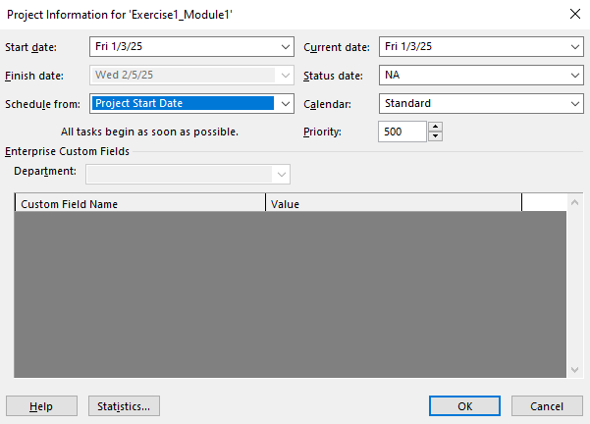

* View Project Timeline, Gant Chart, Network Diagram and capture the result them.

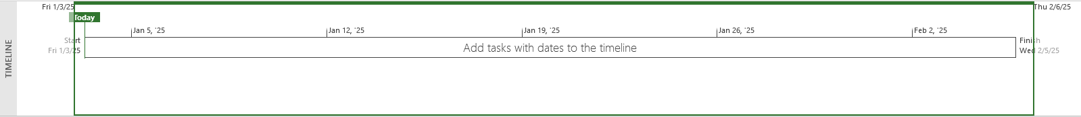

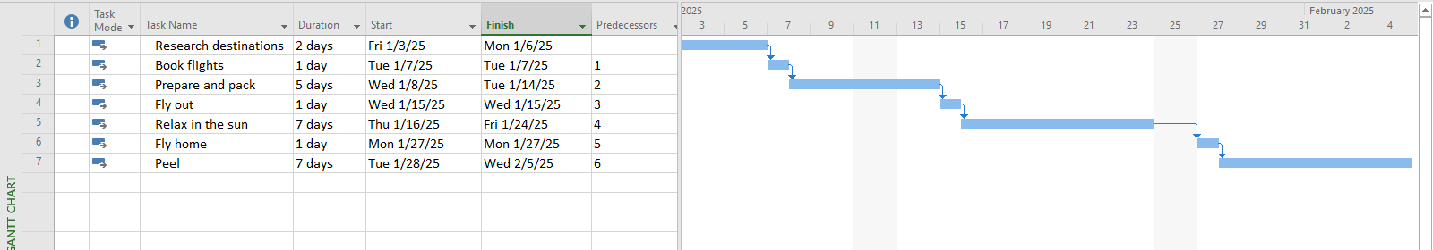

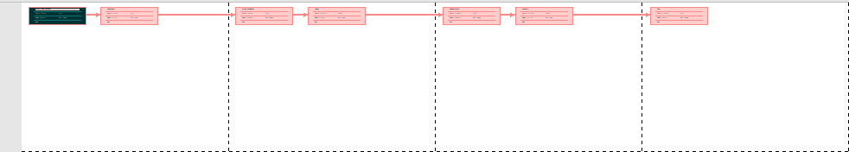

## Exercise 2. Setting duration

Creating the following tasks

|  |  |  |  |
| --- | --- | --- | --- |
| **ID** | **TASK NAME** | **PREDESCESSOR** | **DURATION** |
| **1** | Quarry stone | - | 2 days |
| **2** | Transport stone | 1 | 1 days |
| **3** | Prepare stone | 2 | 5 days |
| **4** | Fill foundations | 1,3 | 1 day |
| **5** | Level ground | 2,3 | 1 day |
| **6** | Measure site | 1 | 7 days |
| **7** | Mark out site | 5 | 5 days |
| **8** | Acquire stone | 2,4 | 3 days |
| **9** | Prepare site | 5,3 | 9 days |
| **10** | Build | 8,9 | 2 days |

* Display the Project Information

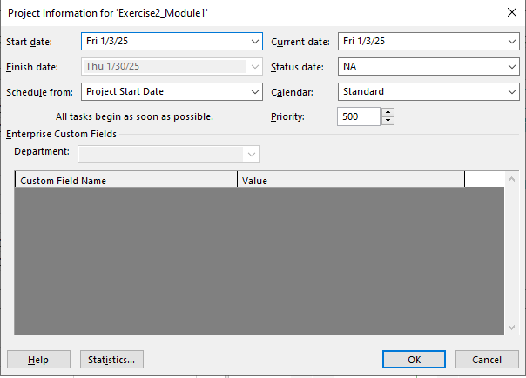

* View Project Timeline, Gant Chart, Network Diagram and capture the result of them.

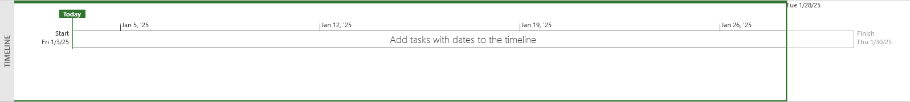

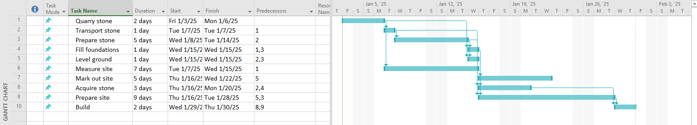

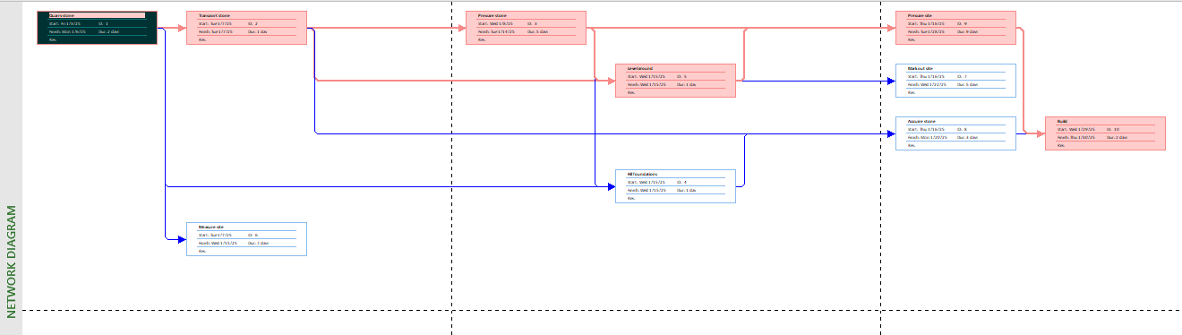

## Exercise 3. Creating phases

Creating the following tasks

|  |  |  |  |
| --- | --- | --- | --- |
| **ID** | **TASK NAME** | **PREDESCESSOR** | **DURATION** |
| **1** | Pre-heat oven | - | 5 mins |
| **2** | Prepare meat | 1 | 5 mins |
| **3** | Prepare veg | 2 | 5 mins |
| **4** | Heat pan | 3 | 5 mins |
| **5** | Fry veg | 4 | 5 mins |
| **6** | Brown meat | 5 | 5 mins |
| **7** | Add stock and bring to a simmer | 6 | 5 mins |
| **8** | Cook in oven | 7 | 45 mins |

* Group the eight tasks so that the first task becomes a summary task (Make a casserole 1 day?)
* Display the Project Information

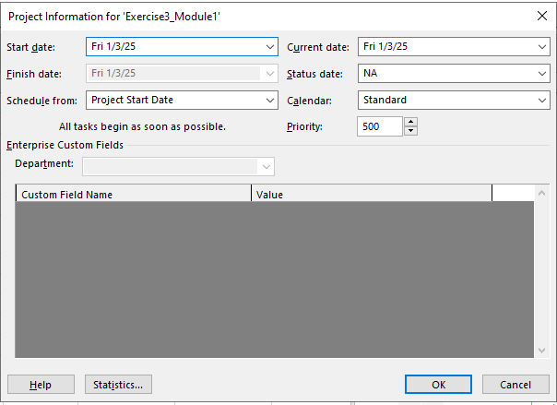

* View Project Timeline, Gant Chart, Network Diagram and capture the result of them.

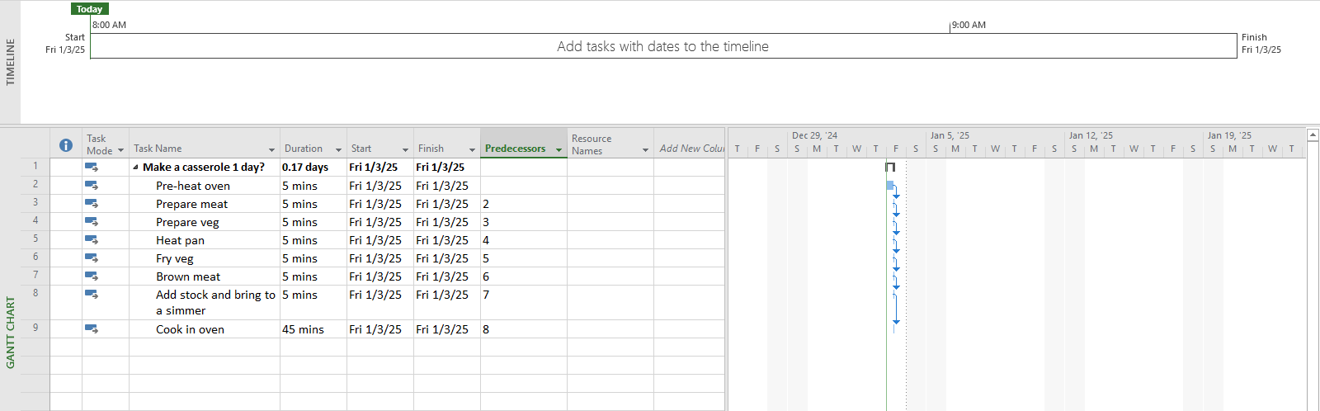

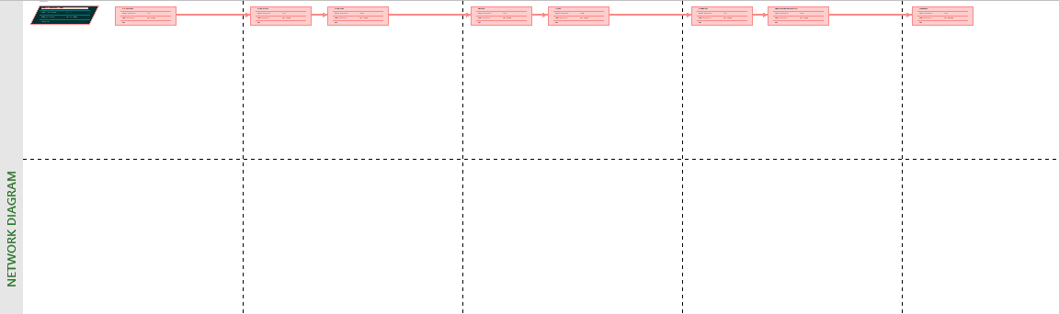

## Exercise 4. Noah - Linking

Create the following links

|  |  |  |  |
| --- | --- | --- | --- |
| **ID** | **TASK NAME** | **PREDESCESSOR** | **DURATION** |
| **1** | Build boat | - | 7 days |
| **2** | Load supplies | 1 | 3 days |
| **3** | Load family | 1 | 6 days |
| **4** | Load animals | 1 | 7 days |
| **5** | Collect animals A-M | 1,4 | 12 days |
| **6** | Collect animals N-Z | 2,4 | 10 days |
| **7** | Float around | 5,6 | 7 days |

* Display the Project Information

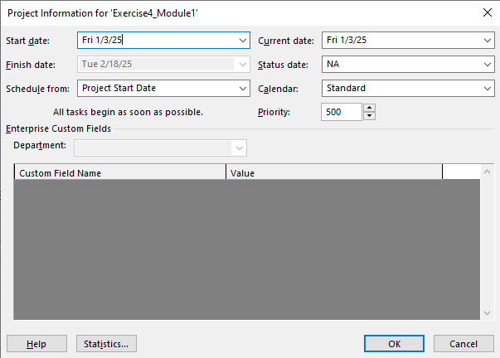

* View Project Timeline, Gant Chart, Network Diagram and capture the result of them.

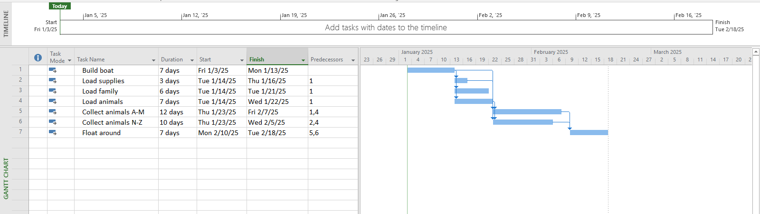

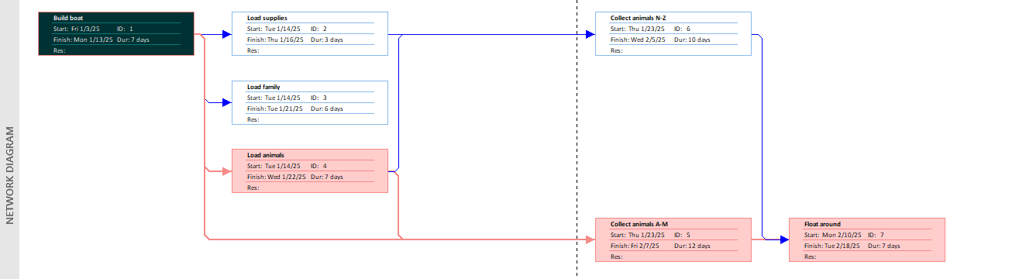

## Exercise 5. Pyramid - Multi level grouping

Create the following links

|  |  |  |  |
| --- | --- | --- | --- |
| **ID** | **TASK NAME** | **PREDESCESSOR** | **DURATION** |
| **1** | *Build a pyramid* | *-* | *1 day?* |
| **2** | *Acquire stone* | 1 | *1 day?* |
| **3** | Quarry stone | 2 | 3 wks |
| **4** | Transport stone | 3 | 5 days |
| **5** | Prepare stone | 4 | 3 wks |
| **6** | *Prepare site* | 5 | *1 day?* |
| **7** | Dig foundations | 6 | 3 wks |
| **8** | Fill foundations | 7 | 2wks |
| **9** | Level ground | 8 | 1wk |
| **10** | Measure site | 9 | 7 days |
| **11** | Mark out site | 10 | 7 days |
| **12** | Build | 11 | 6 mons |

* Group the tasks as indicated above with 3 levels:
* Level 1 at task 1 includes task 2,6,12
* Level 2 at task 2 includes task 3,4,5, task 6 includes task 7,8,9,10,11
* Display the Project Information

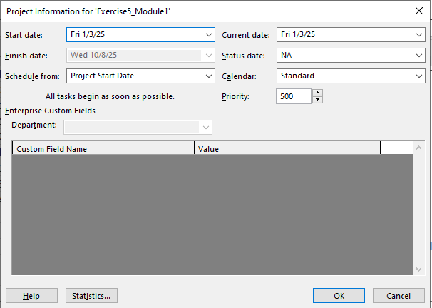

* View Project Timeline, Gant Chart, Network Diagram and capture the result of them.

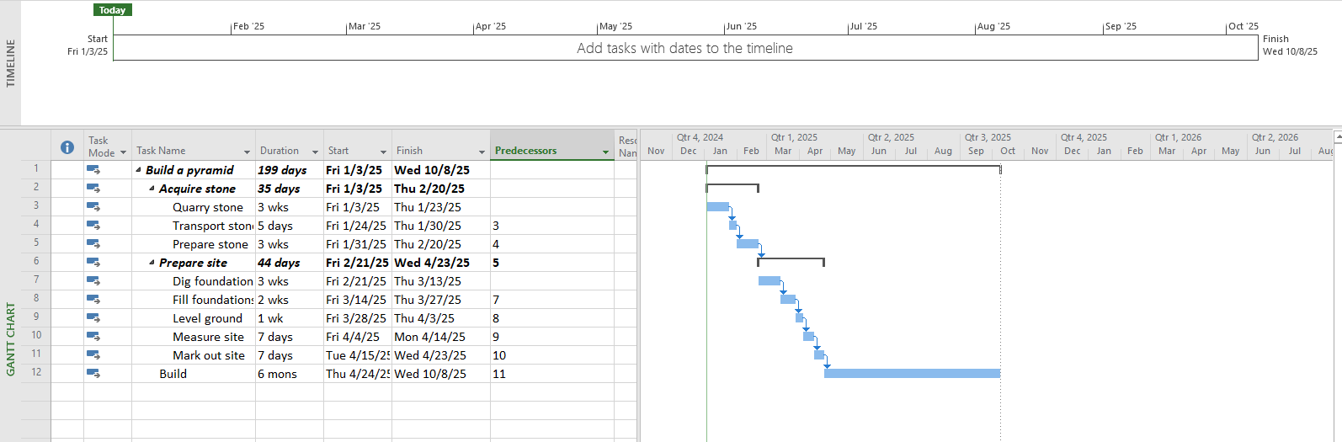

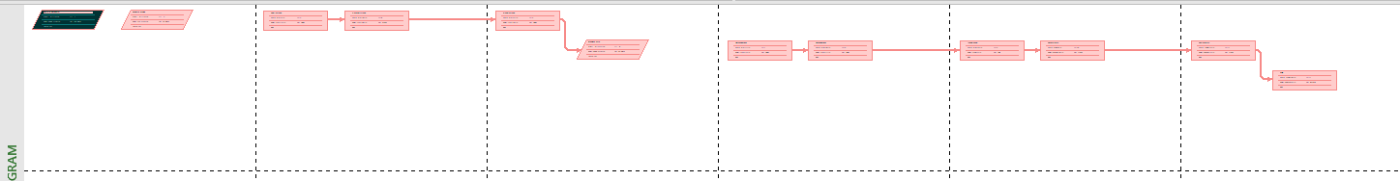

## Exercise 6. Creating a plan for Staff Training

|  |  |  |  |
| --- | --- | --- | --- |
| **ID** | **TASK NAME** | **PREDESCESSOR** | **DURATION** |
| **1** | Start with a skills gap analysis. | - | 7 days |
| **2** | Identify employees for career | 1 | 3 days |
| **3** | Align with employee and company goals. | 2 | 6 days |
| **4** | Help them grow with you | 3 | 7 days |
| **5** | *Use employee development plan* | *4* | *1 days?* |
| **6** | Consider an individual employee | 5 | 2 wks |
| **7** | A succession planning template | 6 | 1wks |
| **8** | *Fit the learning opportunity to the training* | *7* | *1 days?* |
| **9** | Microlearning | 8 | 2 wks |
| **10** | On-the-job training | 9 | 5wks |
| **11** | Augmented reality | 10 | 1wks |
| **12** | Track results to inform your decisions | 11 | 7 days |

* Group the tasks as indicated above with 3 levels:
* Level 1 at task 1,2,3,4,5,8,12.
* Level 2 at task 5 includes task 6,7 and task 8 includes task 9,10,11
* Display the Project Information

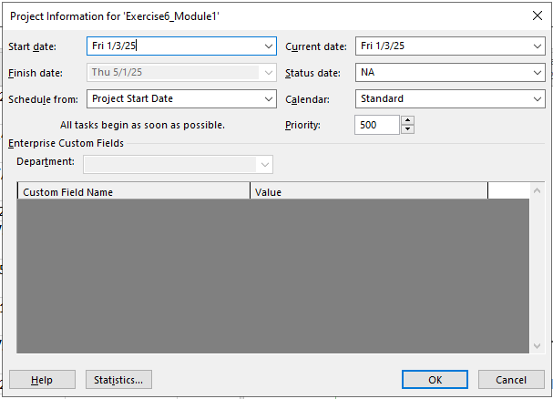

* View Project Timeline, Gant Chart, Network Diagram and capture the result of them.

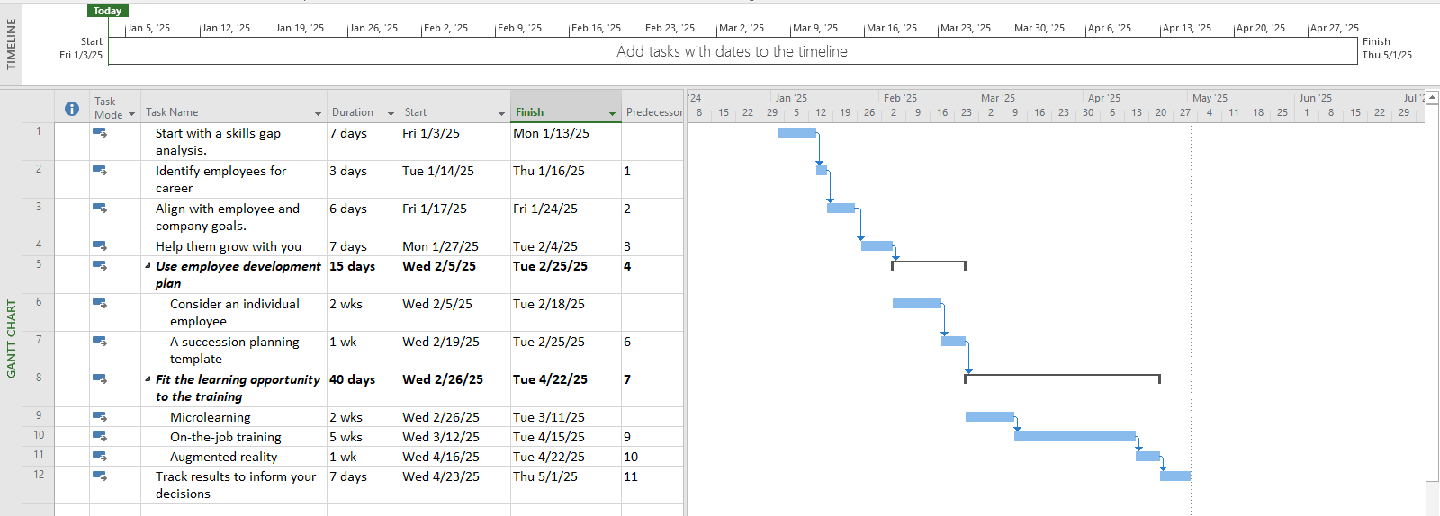



## Exercise 7. Recurring tasks

Create plan for a software project

|  |  |  |  |
| --- | --- | --- | --- |
| **ID** | **TASK NAME** | **PREDESCESOR** | **DURATION** |
| **1** | Planning | - | 1 wk |
| **2** | Requirement documents | 1 | 2 wks |
| **3** | Sign off | 2 | 1 day |
| **4** | Development | 3 | 10 wks |
| **5** | Testing | 4 | 4 wks |
| **6** | Implementation | 5 | 2 wks |
| **7** | Review | 6 | 1 wk |

* Add in a weekly meeting to run throughout the project with the following settings
* Name: Breakfast Meeting
* Duration: 1 hour
* Recurrence: Weekly
* Day: Monday
* Range: 08/01/2025 at 08:00 to end of the project.
* Calendar: Standard
* Display the Project Information

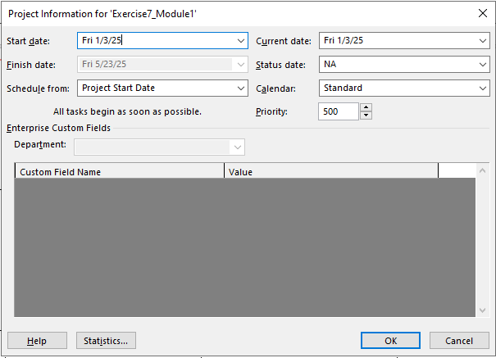

* View Project Timeline, Gantt Chart, Network Diagram and capture the result of them.

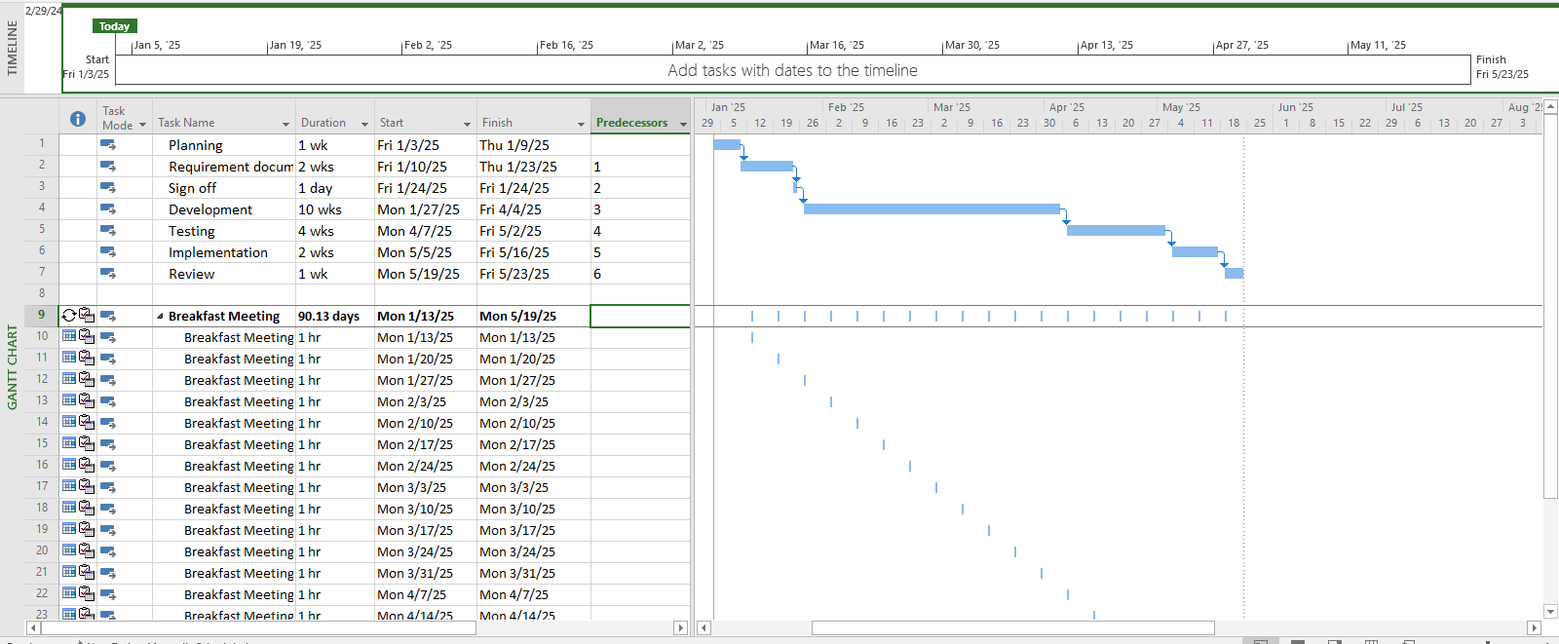

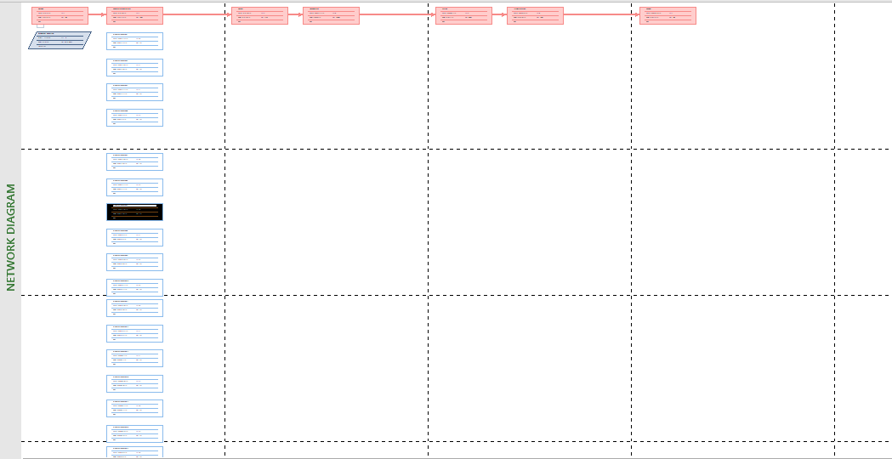

## Exercise 8. Travelling – task calendar

You intend to travel from HCM to Kuala Lumpur, Bangkok and then, come back to HCM. Creating a plan for your trip.

# MODULE 2: CALENDARS AND SCHEDULING

## Exercise 1. Part Time - creating new calendar

Open project file **Ex2 (Module 1)**, Use the Project Information dialog box to:

* A part-time worker will be used on this project. Go to the Change Working Time dialog box

and create a new copy of the Standard calendar, calling it "Part Time".

* Update the working time of your new calendar so that:
* Mondays to Fridays are nonworking time
* The remaining 2 weekdays have working time of 10:00 to 16:00 ( no breaks)
* The Part time has also booked a holiday from 1 to 5 Jan. Create an Exception to their calendar

with a Holiday name and these days as nonworking

* Display the Project Information.

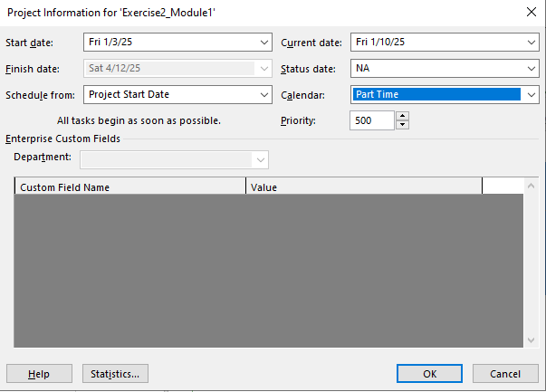

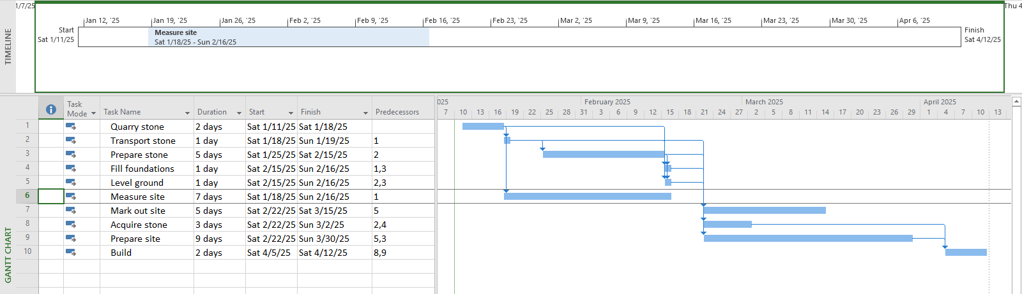

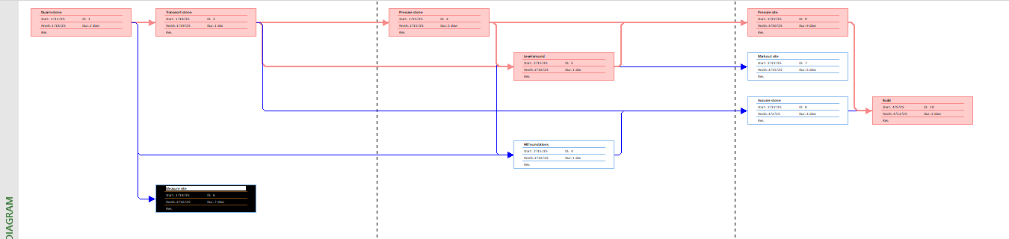

## Exercise 2. Changing Working Time

Open project file **Ex4 (Module 1)** Use the Project Information dialog box to:

* Go to the Change Working Time dialog box and create an Exception called "Tet Holidays" during from 25 Dec 2024 to 3 Jan 2025 into nonworking time.
* Change Work Weeks time of Standard calendar's default working week. This project's standard working time are:
* 08:30 to 17:30 Monday to Thursday (no lunch break)
* 08:30 to 16:00 on Fridays (no lunch break)
* Add a new Work Week to the Standard calendar named "Xmas Slowdown". Use this to

model a 12:30 finish on every weekday from 23 Dec 2024 to 5 Jan 2025.

* Capture the Work weeks time

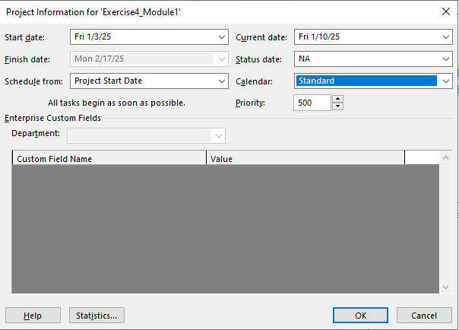

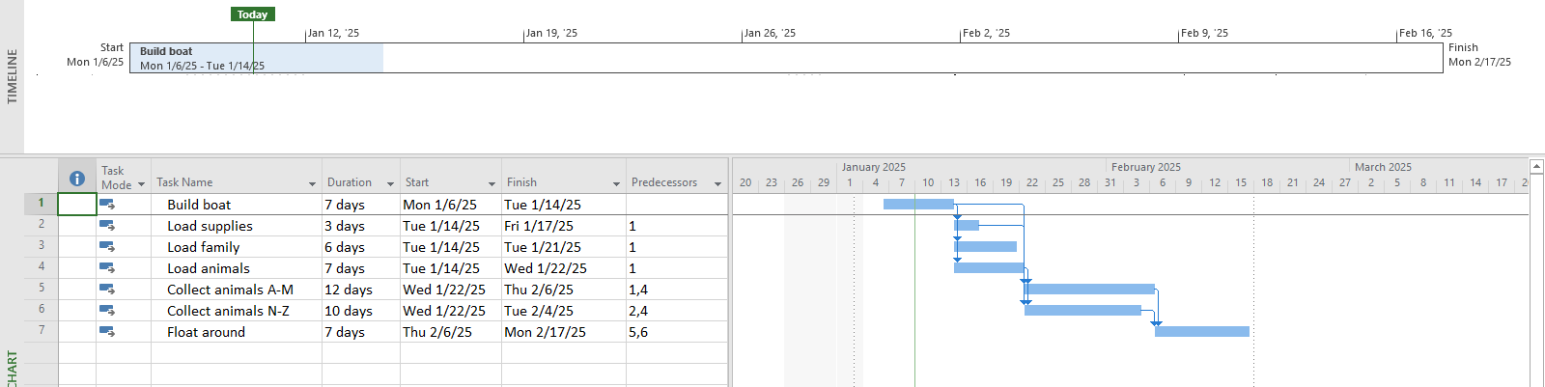

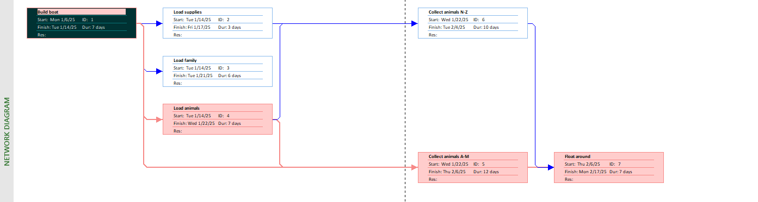

## Exercise 3. Changing Working Time

Open project file **Ex5 (Module 1),** Use the Project Information dialog box to:

* The office will shut down for 2 weeks in the summer. Use the Change Working Time dialog box to create an Exception called "Summer Shutdown" and make the first 14 workdays of August nonworking time
* Create an Exception called “Independence Days” is 2 Sep nonworking time.
* Create an Exception called “International Labor days” is 30 Apr and 1 May nonworking time
* Display the Project Information

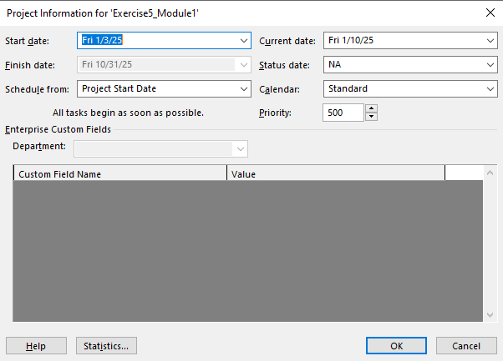

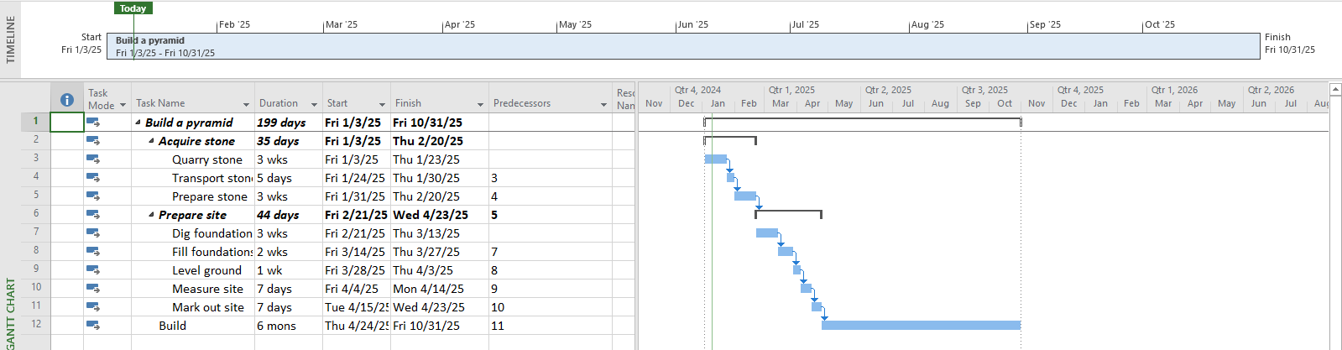

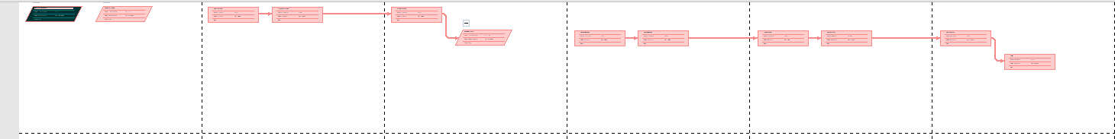

## Exercise 4. Changing Working Time

* Open project file **Ex6 (Module 1),** Use the Project Information dialog box to schedule it to start on Nov 1st of next year.
* Modify the Standard calendar and change the [Default] work week to use the hours shown below:



* Add an exception in the Standard calendar called Recovery with in 7 lates workdays of March is non-working days
* Display the Project Information.

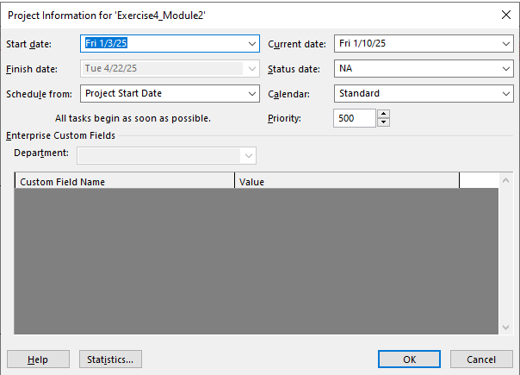

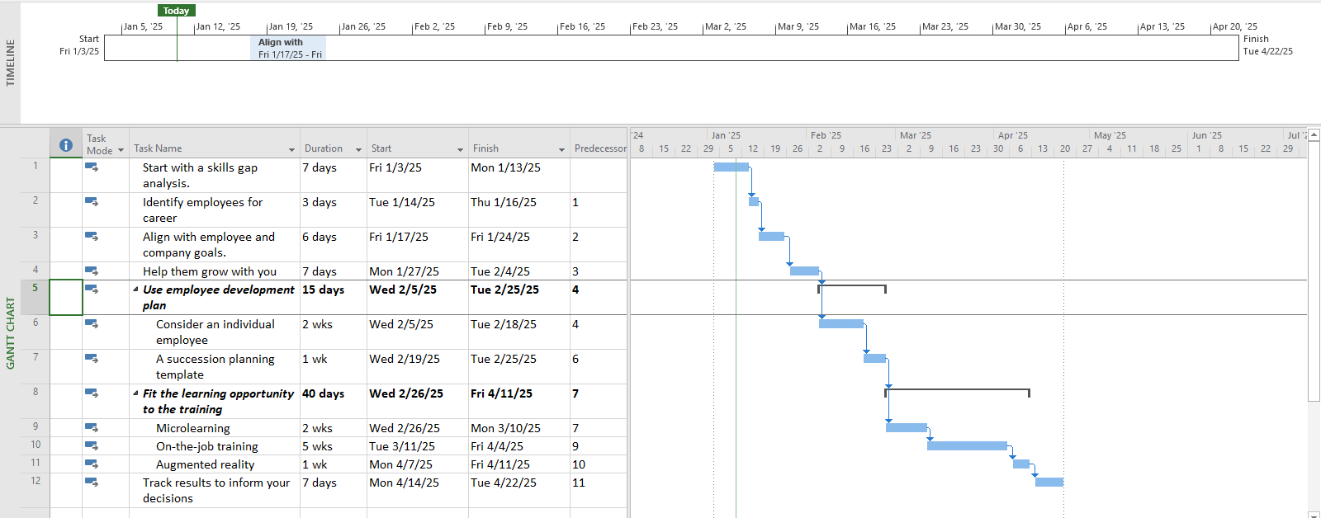



## Exercise 5. Create the private Time for a project

Open project file **Ex7 (Module 1),** Use the **Project Information** dialog box to:

* Create the new Time Work for your project. [NameTimeProject]

{Name: Your Name - Ex: MinhTimeProject}

* Change Work Weeks time of Standard calendar's default working week. This project's standard working time are:
* 08:00 to 12:00 on Mon, Wed, Fri
* 13:00 to 16:00 on Tue, Thu, Sat
* Create an Exception called “International Labor days” is 30 Apr and 1 May nonworking time
* Capture the Work weeks time

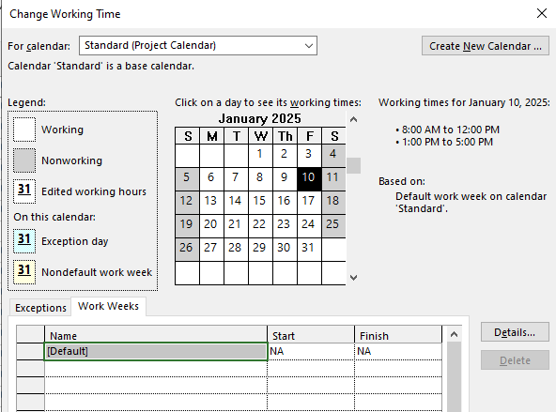

* Display the Project Information

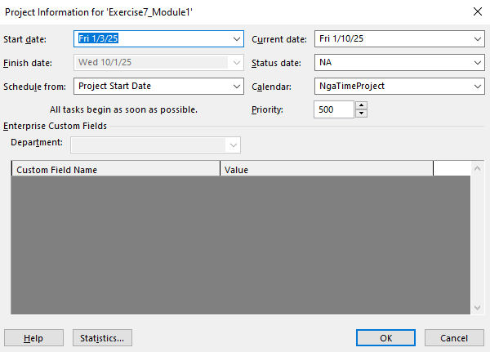

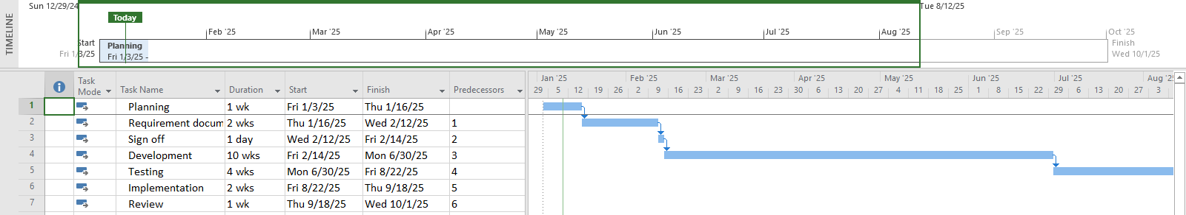

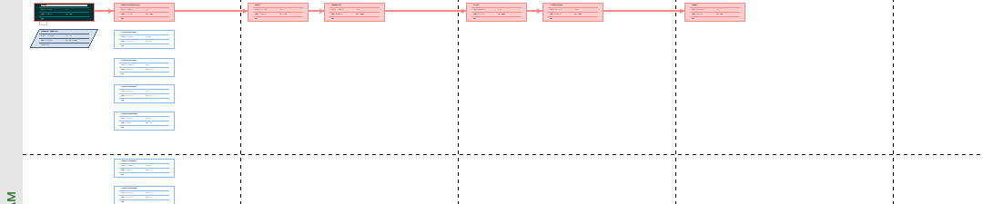

## Exercise 6. Your project

* Create your plan from Monday to Sunday. It will list all of your activities, your time you spend and resources joining in each task.
* Create a new calendar called **Student** based on the **Standard** calendar.
* Change the **[Default]** work week so that the hours match to your calendar everyday
* Using Note function in MP 2010 to take note for important tasks in your plan.

# 

# MODULE 3: WORKING WITH TASKS

## Exercise 1. Changing Working Time (Start Date 1/3/2025)

|  |  |  |  |
| --- | --- | --- | --- |
| ID | TASK NAME | PREDECESSOR | DURATION |
| 1 | clean machine | NaN | 5 days |
| 2 | load raw materials | 1 | 3 days |
| 3 | prime machine | 2 | 3 days |
| 4 | Test run | 3 | 1 day |
| 5 | clean machine | 4 | 5 days |
| 6 | load raw materials | 5 | 3 days |
| 7 | prime machine | 6 | 3 days |
| 8 | Test run | 7 | 1 day |

Create the summary tasks for series tasks below:

* Summary task name is **Boy’s Toy** for tasks 1,2,3,4
* Summary task name is **Girl’s Toy** for tasks 5,6,7,8
* Add the **Ready for production task** (0 day) that is the end task of the task list
* Summary Task name is **Workshop** for **Boy’s Toy**, **Girl’s Toy, and Ready for production tasks**
* Display the Project Information.

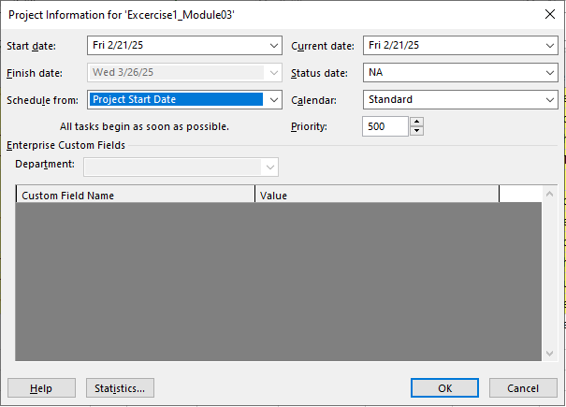

* View Project Timeline, Gantt Chart, view CP, Total Slack and capture the result of them

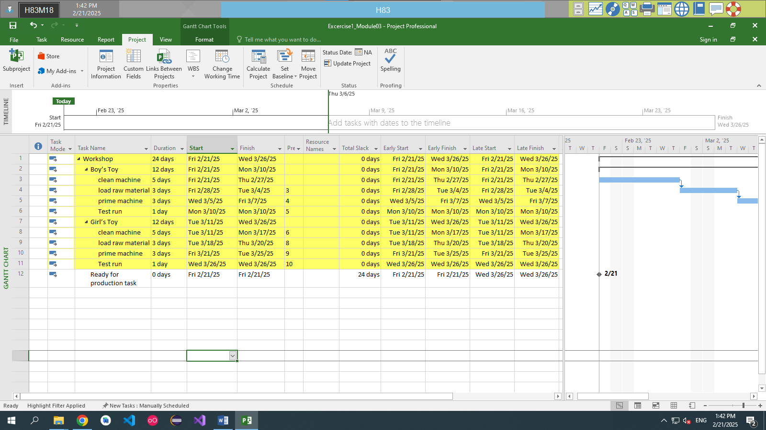

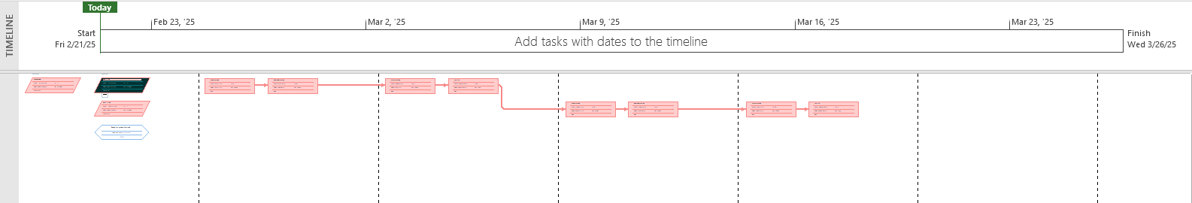

## Exercise 2. Changing Working Time (Start Date 1/03/2025)

* Using the diagram below, create a list of tasks to model this process.

|  |  |  |  |
| --- | --- | --- | --- |
| **ID** | **TASK NAME** | **PREDECESSOR** | **DURATION** |
| 1 | Visit estate agents |  | 1 days |
| 2 | View properties | 1 | 2 days |
| 3 | Decide what to buy | 2 | 5 days |
| 4 | Make offer | 3 | 0 day |
| 5 | Wait for decision | 4 | Don't know |
| 6 | Offer accepted | 5 | 0 days |

* Create the summary task is **Buy a shop** that contains all tasks in the project.
* Establish the duration of **Wait for a decision task** is 7 days.
* Change the duration of **View properties task** to **7 days**.
* Display the Project Information.

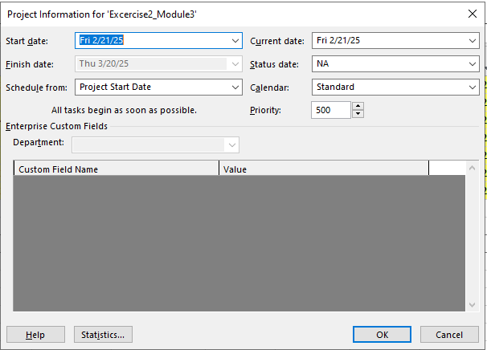

* View Project Timeline, Gantt Chart, view CP, Total Slack and capture the result of them.

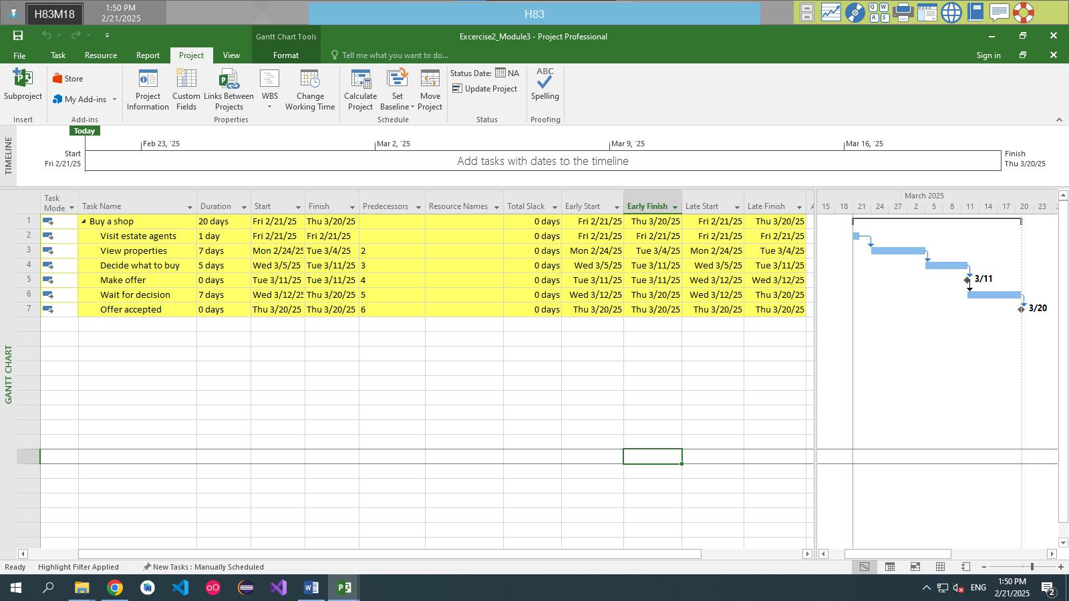

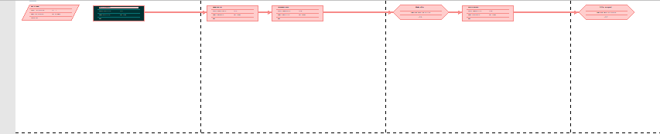

## Exercise 3. Scheduling – Task dependencies

**Create the list of tasks to model this processing (Start date: 1/3/2025)**

|  |  |  |
| --- | --- | --- |
| **ID** | **TASK NAME** | **Duration** |
| 1 | Creating architectural plans | 3 wks |
| 2 | Submit plans for approval | 1 mon |
| 3 | Order materials | 8 days |
| 4 | Erect fencing | 3 days |
| 5 | Erect site building | 4 days |
| 6 | Clear and level site | 3 wks |
| 7 | Prepare drainage infrastructure | 1 wk |
| 8 | Prepare cabling infrastructure | 1 wk |
| 9 | Pour foundations | 4 days |
| 10 | Erect steelwork | 3 mons |
| 11 | Erect wall | 2 mons |
| 12 | Install roofing superstructure | 2 wks |
| 13 | Install roofing retracting mechanism | 1 wk |
| 14 | Erect seating tiers | 3 wks |
| 15 | Fit all windows and doors | 2 wks |
| 16 | Install electrical cabling | 1 wk |
| 17 | Install electrical fittings and fixtures | 2 wks |
| 18 | Install all plumbing | 2 wks |
| 19 | Install plumbing fixtures and fittings | 1 wk |
| 20 | Lay astro turf | 1 wk |
| 21 | Erect handrails and fencing | 2 wks |
| 22 | Paint rooms, fixtures, fittings, etc. | 1 mon |
| 23 | Install PA system | 2 days |
| 24 | Install video imaging equipment | 3 days |
| 25 | Fit out control room | 1 wk |
| 26 | Test roof mechanism | 1 wk |
| 27 | Test PA system | 2 days |
| 28 | Test video imaging equipment | 2 days |
| 29 | Test control room equipment | 1 wk |
| 30 | Obtain official occupancy | 1 day |
| 31 | Obtain safety certification | 2 days |
| 32 | Official opening | 1 day |

**Create the summary tasks for series tasks below:**

* Summary task name is **Planning (20 days)** for tasks 1,2,3.
* Summary task name is **Site Works (15 days)** form task 4 to task 8.
* Summary task name is **Building Construction (60 days)** form task 9 to task 14.
* Summary task name is **Fit Out (20 days)** form task 15 to task 25.
* Summary task name is **Commissioning (5 days)** form task 26 to the end task.

**Create the milestones for this project below:**

|  |  |  |
| --- | --- | --- |
| **No** | **Milestone** | **At End Of phrases** |
| 1 | Planning Completed | Planning |
| 2 | Site Works Completed | Site works |
| 3 | Building Construction Completed | Building Construction |
| 4 | Fit Out Completed | Fit out |
| 5 | Commissioning Completed | Commissioning |

**Creating Dependencies in Task Entry**

|  |  |  |  |
| --- | --- | --- | --- |
| **ID** | **TASK NAME** | **Duration** | **Dependencies** |
| **1** | Planning |  |  |
| **2** | Creating architectural plans | 3 wks | 1 |
| **3** | Submit plans for approval | 1 mon | 2 |
| **4** | Order materials | 8 days | 3 |
| **5** | Planning Completed | 0 | 2, 3, 2004 |
| **6** | Site works |  | 5 |
| **7** | Erect fencing | 3 days | 6 |
| **8** | Erect site building | 4 days | 7 |
| **9** | Clear and level site | 3 wks | 8 |
| **10** | Prepare drainage infrastructure | 1 wk | 9 |
| **11** | Prepare cabling infrastructure | 1 wk | 9 |
| **12** | Site works Completed | 0 | 7, 8, 9, 10, 11 |
| **13** | Building Construction |  | 12 |
| **14** | Pour foundations | 4 days | 13 |
| **15** | Erect steelwork | 3 mons | 14 |
| **16** | Erect wall | 2 mons | 15 |
| **17** | Install roofing superstructure | 2 wks | 16 |
| **18** | Install roofing retracting mechanism | 1 wk | 17 |
| **19** | Erect seating tiers | 3 wks | 18 |
| **20** | Building Construction Completed | 0 | 14, 15, 16, 17, 18, 19 |
| **21** | Fit Out |  | 20 |
| **22** | Fit all windows and doors | 2 wks | 21 |
| **23** | Install electrical cabling | 1 wk | 21 |
| **24** | Install electrical fittings and fixtures | 2 wks | 23 |
| **25** | Install all plumbing | 2 wks | 21 |
| **26** | Install plumbing fixtures and fittings | 1 wk | 25 |
| **27** | Lay astro turf | 1 wk | 21 |
| **28** | Erect handrails and fencing | 2 wks | 21 |
| **29** | Paint rooms, fixtures, fittings, etc. | 1 mon | 28 |
| **30** | Install PA system | 2 days | 23 |
| **31** | Install video imaging equipment | 3 days | 23 |
| **32** | Fit out control room | 1 wk | 29, 30, 31 |
| **33** | Fit Out Completed | 0 | 22, 23, 24, 25, 26, 27, 28, 29, 30, 31, 32 |
| **34** | Commissioning |  | 33 |
| **35** | Test roof mechanism | 1 wk | 34 |
| **36** | Test PA system | 2 days | 33 |
| **37** | Test video imaging equipment | 2 days | 33 |
| **38** | Test control room equipment | 1 wk | 35, 36, 37 |
| **39** | Obtain official occupancy | 1 day | 38 |
| **40** | Obtain safety certification | 2 days | 39 |
| **41** | Official opening | 1 day | 40 |
| **42** | Commissioning Completed | 0 | 35, 36, 37, 38, 39, 40, 41 |

Display the Project Information.

* View the project in Gantt Chart and define CP and Project Slack
* Choose **Gantt Chart Format** tab => check on ***Critical Tasks*** in ***Bar Styles.***



* *Check on* ***Slack*** in ***Bar Styles*** slack lines in non-critical tasks
* On the table data Add column **Late Start**, **Late Finish**, **Total Slack**

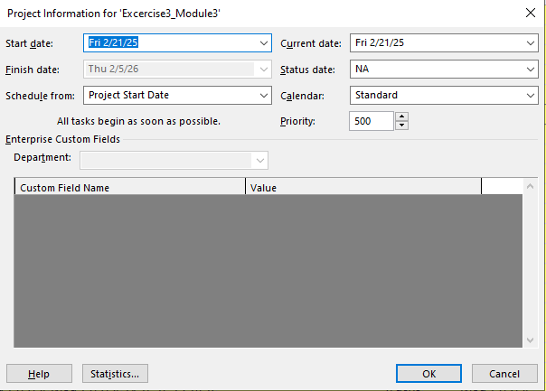

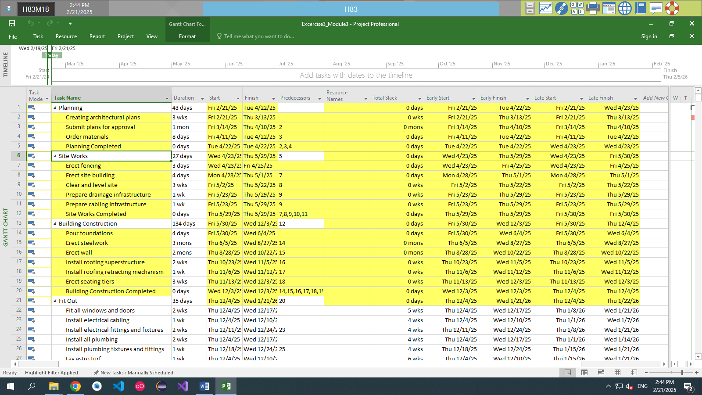

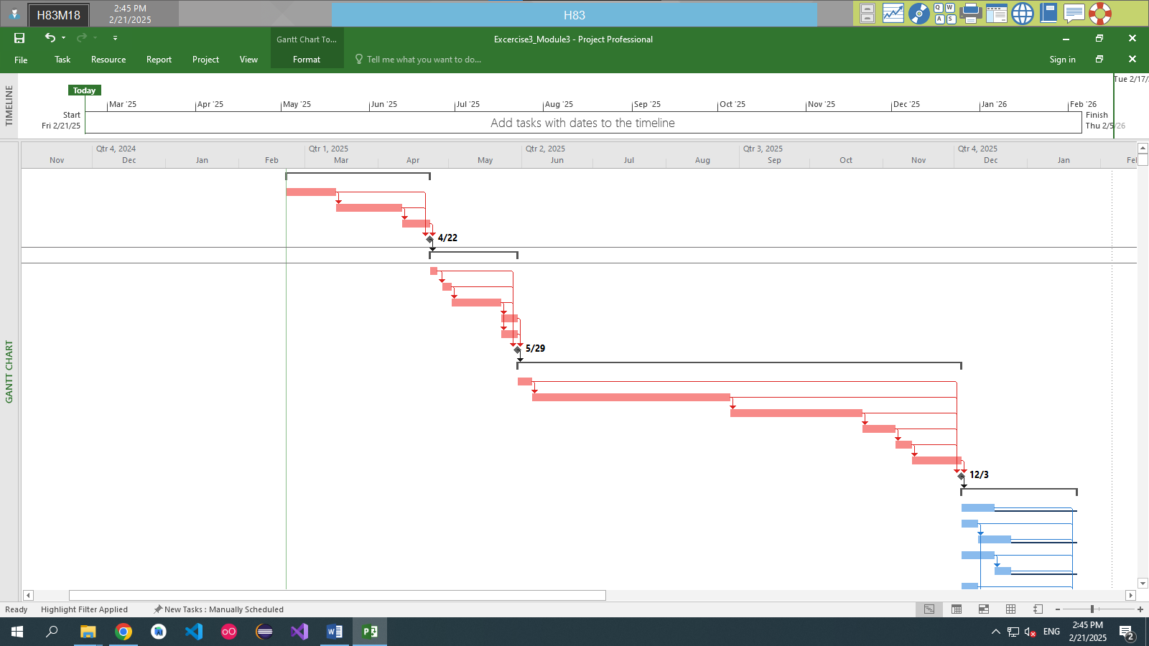

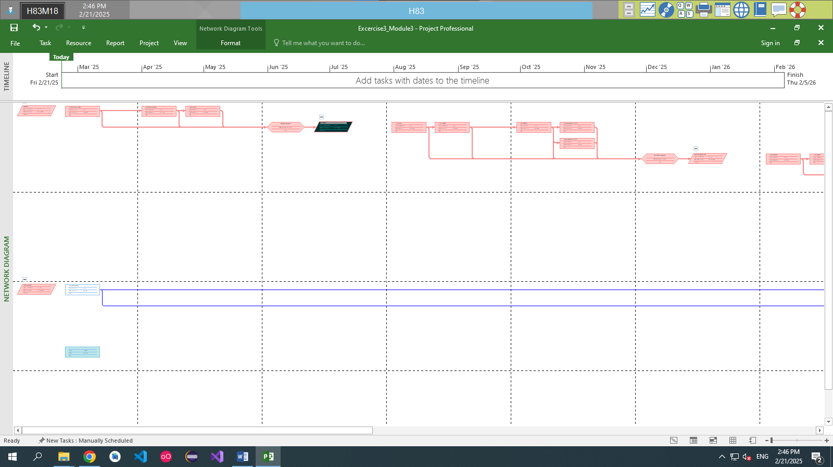

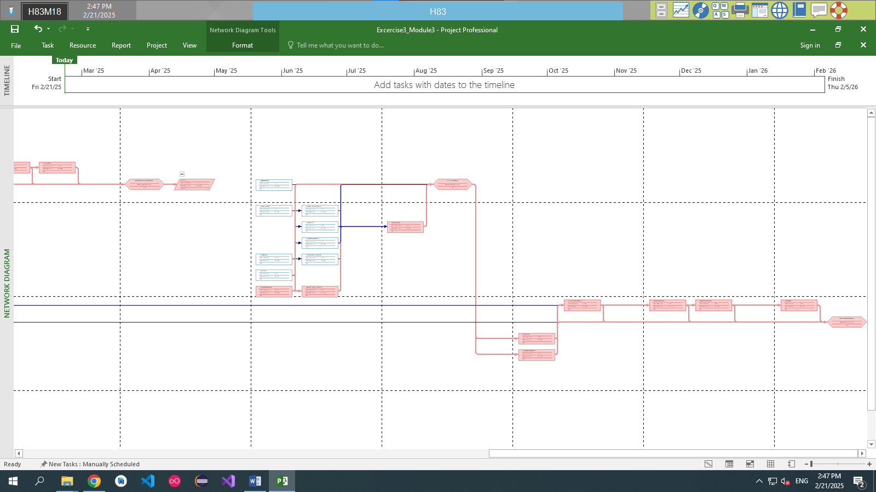

# 

# MODULE 4: ASSIGNING THE RESOURCE FOR A PROJECT

Capture the Project Information before and after assigning the resource

## Exercise 1. Entering work resource

* Open the Exercise 1 (Module 3)
* Tab View **=>** Resource Sheet
* Add the resource for this project bellow: Type Work (person)

|  |  |  |  |  |  |
| --- | --- | --- | --- | --- | --- |
| **STT** | **Name** | **Initials** | **Groups** | **Max. Units** | **Std. Rate** |
| 1. | David | Dav | Consultant | 100% | 8 |
| 2. | Brian | Bri | Staff | 200% | 7 |
| 3. | Mary | Mar | Staff | 100% | 7 |
| 4. | John | Joh | Staff | 100% | 7 |
| 5. | Worker 1: Liam | W1 | Worker | 300% | 6 |
| 6. | Worker 2: Chang | W2 | Worker | 200% | 6 |

* Assign the resource for each task

Tab Task **=>** Gantt Chart **=>** Add Column Resource Name, Cost

Select the task that you want to assign the resource

|  |  |  |
| --- | --- | --- |
| **ID** | **TASK NAME** | **RESOURCE** |
| 1 | clean machine | Worker 1, David |
| 2 | load raw materials | Worker 2 |
| 3 | prime machine | Mary |
| 4 | Test run | Brian |
| 5 | clean machine | Worker 1 |
| 6 | load raw materials | Worker 2 |
| 7 | prime machine | John |
| 8 | Test run | David |

Capture images:

- Gantt Chart (Resource Name, Cost Column)

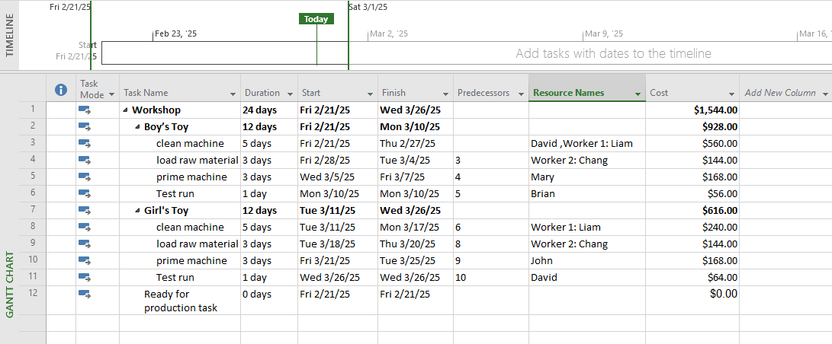

- Display the Project Information (Statics): Duration, Hours, Cost

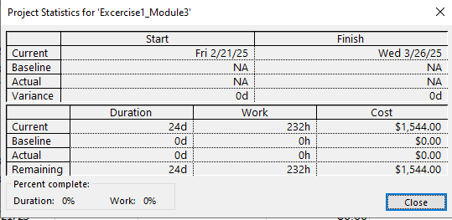

- Resource Sheet

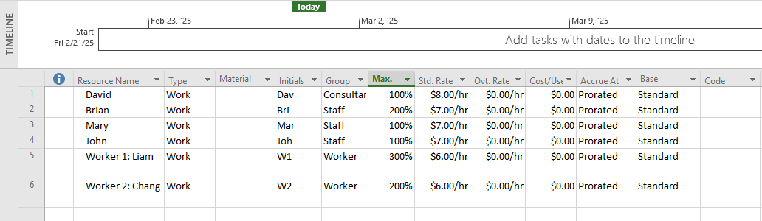

- Resource Usage

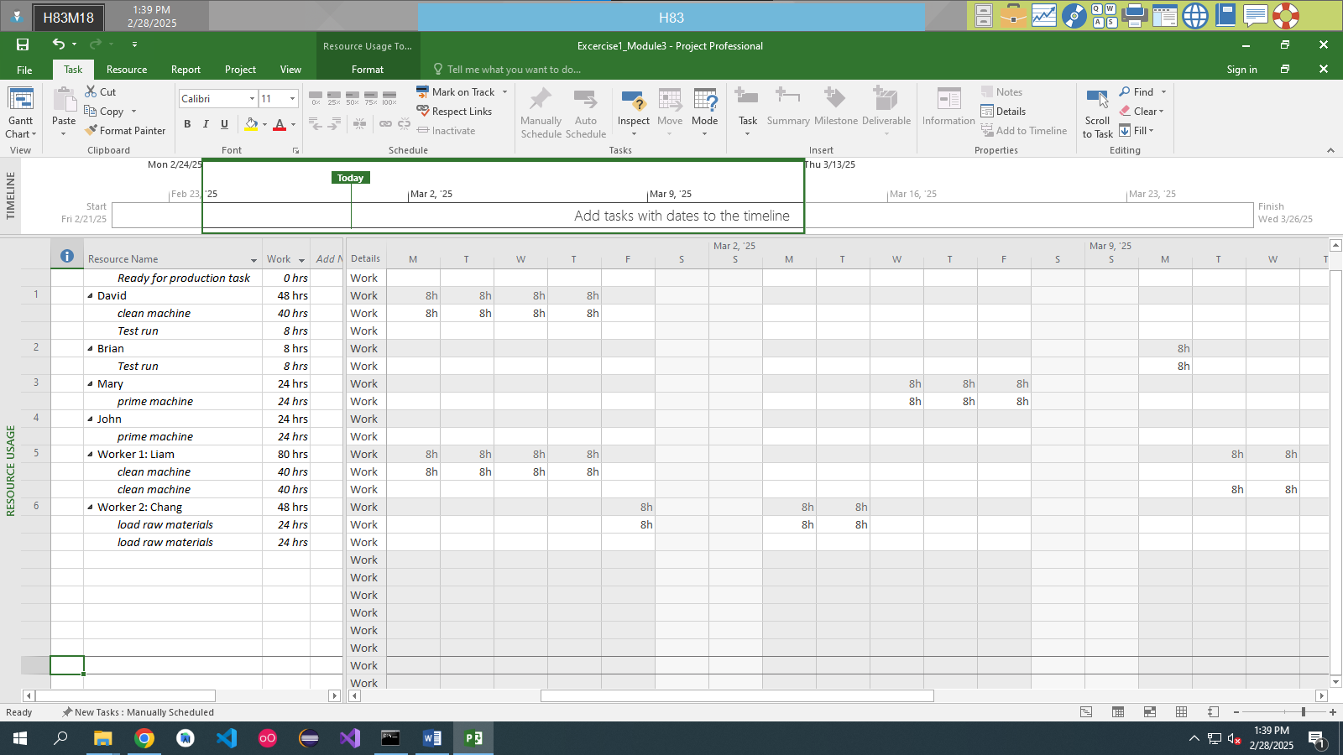

## Exercise 2. Changing Working Time (Start Date 1/11/2024)\

* Open the Exercise 2 (Module 3)
* Tab View => Resource Sheet
* Add the resource for this project bellow: Type Material

|  |  |  |  |  |  |  |
| --- | --- | --- | --- | --- | --- | --- |
| **STT** | **Name** | **Type** | **Materials** | **Initials** | **Groups** | **Std. Rate** |
| 1. | MDF | Material | Sheet | Md | Material | 20 |
| 2. | Flooring | Material | Pack | Fl | Material | 80 |
| 3. | Purple Material | Material | Roll | Pu | Material | 30 |
| 4. | Orange Material | Material | Roll | Or | Material | 120 |

* Assign the resource for each task

Tab Task => Gantt Chart => Add Column Resource Name, Cost

Select the task that you want to assign the resource

Select Tab Resource => Assign Resource

The information of resource that will assign for the task

|  |  |  |
| --- | --- | --- |
| **ID** | **TASK NAME** | **RESOURCE** |
| 1 | Visit estate agents | MDF [2] |
| 2 | View properties | Flooring [2] |
| 3 | Decide what to buy | Purple Material [1] |
| 4 | Make offer | Flooring [1], Purple Material [1] |
| 5 | Wait for decision | Flooring [1], Orange Material [1] |
| 6 | offer a accepted | Orange Material [2] |

Capture images:

- Gantt Chart (Resource Name, Cost Column)

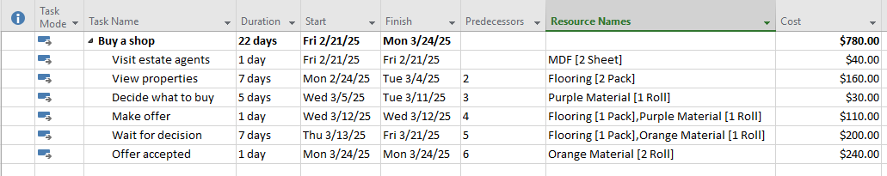

- Display the Project Information (Statics): Duration, Hours, Cost

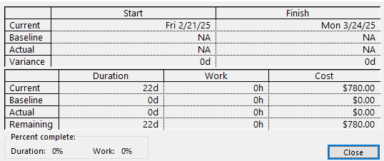

- Resource Sheet

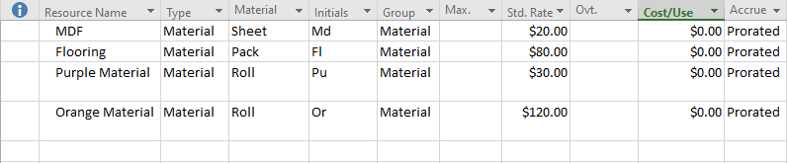

- Resource Usage

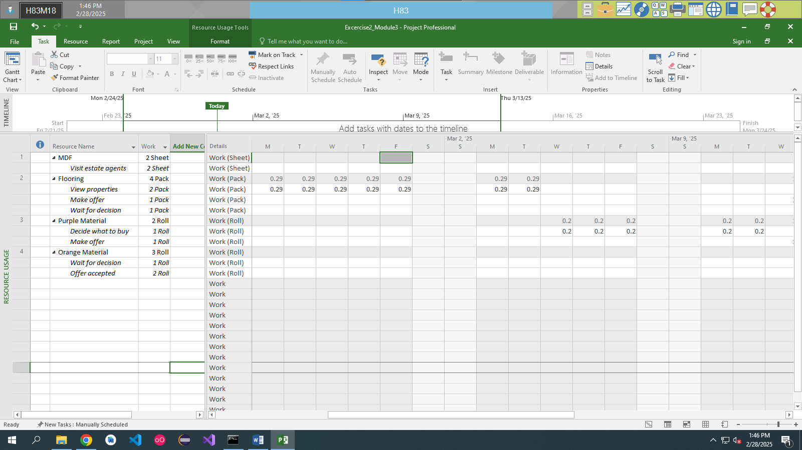

## Exercise 3. Entering work resource

* **Create the project bellowing:**

|  |  |  |  |
| --- | --- | --- | --- |
| **ID** | **TASK NAME** | **PREDECESSOR** | **DURATION** |
| **1** | Planning | - | 1 wk |
| **2** | Requirement documents | 1 | 2 wks |
| **3** | Sign off | 2 | 1 day |
| **4** | Development | 3 | 10 wks |
| **5** | Testing | 4 | 4 wks |
| **6** | Implementation | 5 | 2 wks |
| **7** | Review | 6 | 1 wk |

* **Tab View => Resource Sheet / Tab Task => Resource Sheet**
* **Add the resource for this project bellow: Type Work/Material**

|  |  |  |  |  |  |  |
| --- | --- | --- | --- | --- | --- | --- |
| **STT** | **Name** | **Type** | **Materials** | **Initials** | **Groups** | **Std. Rate** |
| **1.** | PM | Work | Sponsor | PM | Staff | 10 |
| **2.** | Designer | Work |  | Ds | Staff | 6 |
| **3.** | Developer | Work |  | Dp | Staff | 8 |
| **4.** | Tester | Work |  | Tt | Staff | 6 |
| **5.** | Maintainer | Work |  | M | Staff | 5 |
| **6.** | Operating System | Material | Unit | OS | Material | 120 |
| **7.** | Internet Provider | Material | Unit | ISP | Material | 100 |
| **8.** | Cable | Material | M | Cb | Material | 1 |
| **9.** | Visual Studio | Material | Unit | VS | Material | 20 |

* **Assign the resource for each task**

|  |  |  |  |
| --- | --- | --- | --- |
| **ID** | **TASK NAME** | **WORK** | **MATERIAL** |
| **1** | Planning | PM |  |
| **2** | Requirement documents | PM, Designer |  |
| **3** | Sign off | PM |  |
| **4** | Development | Developer | Operating System [1], Visual Studio [1] |
| **5** | Testing | Tester |  |
| **6** | Implementation | Maintainer | Operating System, Visual Studio, Cable [100] |
| **7** | Review | PM, Maintainer |  |

**Capture images:**

**- Gantt Chart (Resource Name, Cost Column)**

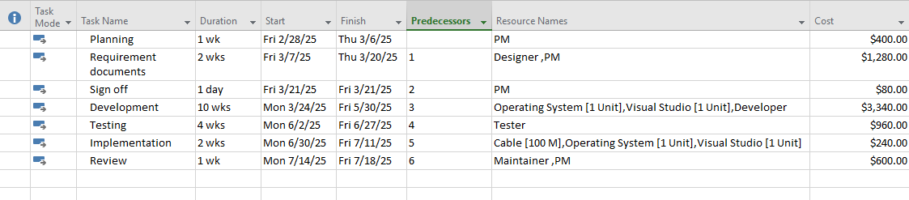

**- Display the Project Information (Statics): Duration, Hours, Cost**

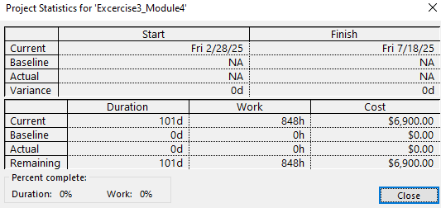

**- Resource Sheet**

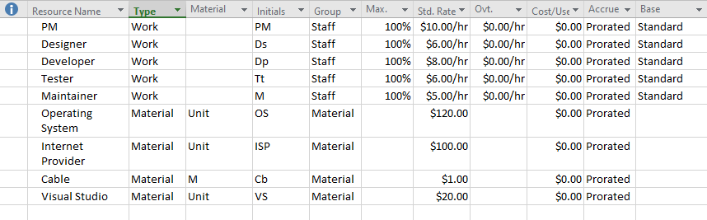

**- Resource Usage**

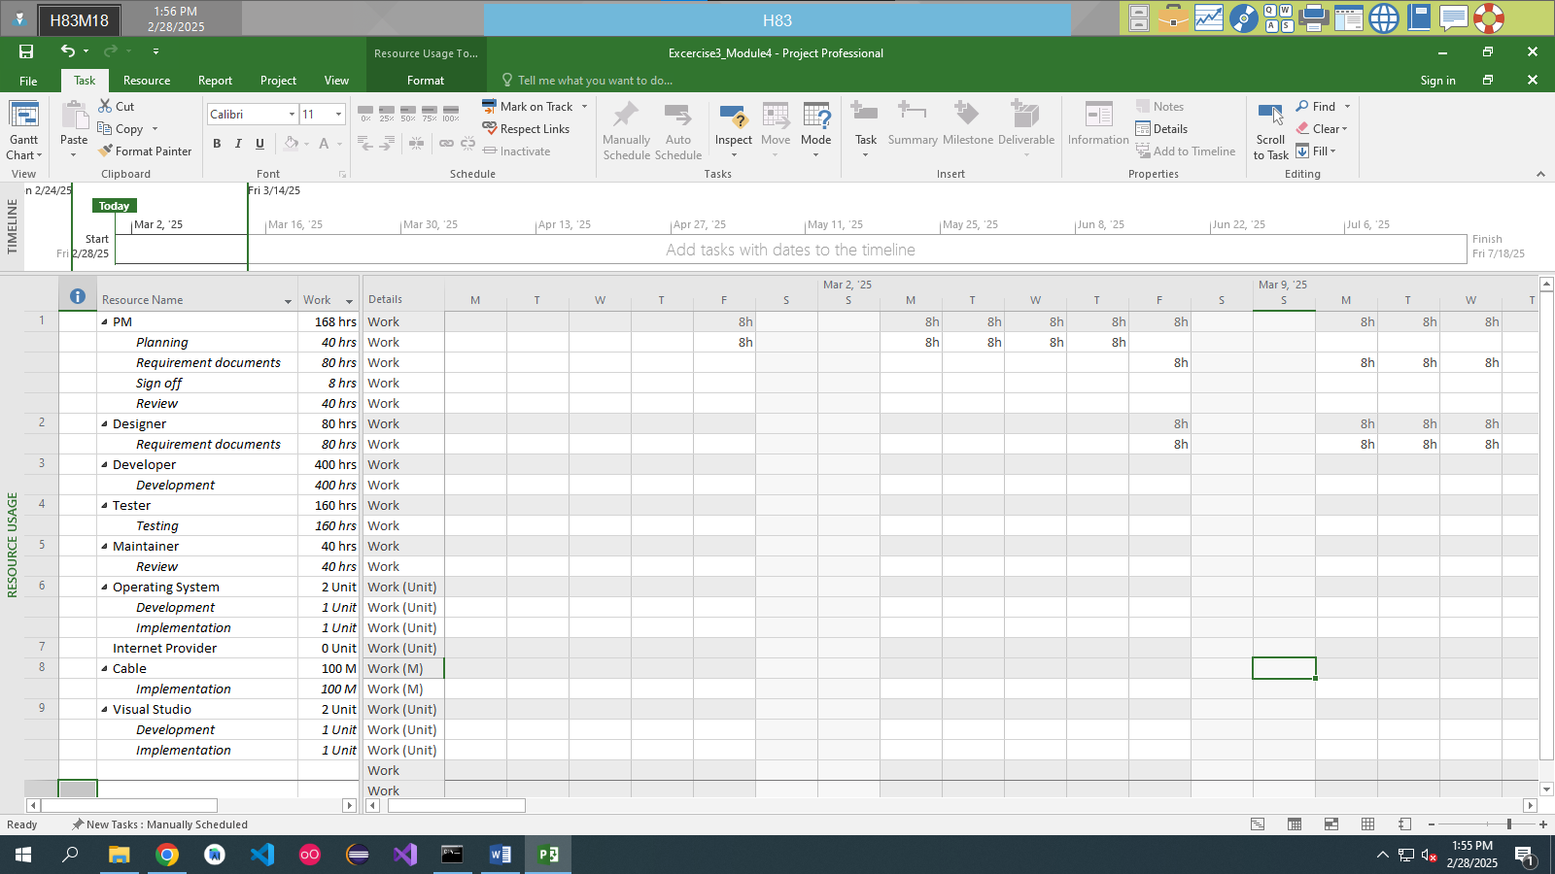

## Exercise 4. Entering work resource

* Capture the Project Information before and after assigning the the source.
* Open the Exercise 3 (Module 3)
* Tab View => Resource Sheet => Resource Views
* Establish the resource that type is work (default) for the project below:

|  |  |  |  |  |  |
| --- | --- | --- | --- | --- | --- |
| **STT** | **Name** | **Initials** | **Groups** | **Max. Units** | **Std. Rate** |
| **1.** | Architect | Arc | Consultant | 100% | 9 |
| **2.** | Draftsperson | Dft | Staff | 200% | 7 |
| **3.** | Building Clerk | BC | Staff | 100% | 8 |
| **4.** | Supervisor | Sup | Staff | 100% | 12 |
| **5.** | Rigger | Rig | Wages | 600% | 5 |
| **6.** | Boilermaker | BM | Wages | 600% | 5 |
| **7.** | Welder | Weld | Wages | 500% | 6 |
| **8.** | Carpenter | Car | Wages | 800% | 7 |
| **9.** | Painter | Ptr | Wages | 500% | 6 |
| **10.** | Labourer | Lab | Wages | 1000% | 6 |
| **11.** | Driver | Drv | Wages | 300% | 8 |
| **12.** | No Barrier Fencing | NBF | Contractor | 100% | 3 |
| **13.** | Rock Solid Concrete | RSC | Contractor | 100% | 4 |
| **14.** | Listen Ear Audio | LEA | Contractor | 100% | 5 |
| **15.** | In Focus Video | IFV | Contractor | 100% | 5 |
| **16.** | Pure Grass Turf | PGT | Contractor | 100% | 5 |
| **17.** | Building Inspector | BI | Government | 100% | 5 |
| **18.** | High Jib Crane | HJC | Equipment | 100% | 7 |
| **19.** | Grader | Grd | Equipment | 200% | 6 |
| **20.** | Air Compressor | AC | Equipment | 100% | 7 |
| **21.** | Utility Ute | Ute | Equipment | 200% | 5 |
| **22.** | Electrician | Cap | Staff | 400% | 7 |
| **23.** | Plumber | Plu | Staff | 400% | 5 |

* **Establish the resource that type is material for the project below at the of Resource list above:**

|  |  |  |  |  |  |  |
| --- | --- | --- | --- | --- | --- | --- |
| **STT** | **Name** | **Type** | **Materials** | **Initials** | **Groups** | **Std. Rate** |
| **24.** | Astro Turf | Material | Square Metre | Grass | Material | 12 |
| **25.** | Paint | Material | Ultre | Ute | Paint | 20 |

* **Assign the resource for each task in the project**

|  |  |  |
| --- | --- | --- |
| **ID** | **TASK NAME** | **RESOURCE** |
| **1** | Planning |  |
| **2** | Creating architectural plans | Architect, Draftsperson (200%), Building Clerk (25%) |
| **3** | Submit plans for approval | Architect |
| **4** | Order materials | Draftsperson, Building Clerk |
| **5** | Planning Completed |  |
| **6** | Site works |  |
| **7** | Erect fencing | No Barrier Fencing |
| **8** | Erect site building | Carpenter (400%), Supervisor, Laborer |
| **9** | Clear and level site | Supervisor, Grader (200%), Driver (200%) |
| **10** | Prepare drainage infrastructure | Supervisor (50%), Plumber (200%) |
| **11** | Prepare cabling infrastructure | Supervisor (50%), Electrician (300%) |
| **12** | Site works Completed |  |
| **13** | Building Construction |  |
| **14** | Pour foundations | Rock Solid Concrete |
| **15** | Erect steelwork | Supervisor (50%), Rigger (600%), Boilermaker (600%), Welder (500%), Laborer (600%), Driver (200%), High Jib Crane, Utility |
| **16** | Erect wall | Supervisor [50%], Carpenter [700%], Laborer [400%], Driver, Grader, Air Compressor, Electrician [75%], Plumber [25%] |
| **17** | Install roofing superstructure | Supervisor [50%], Rigger [500%], Boilermaker [500%], Welder [300%], Laborer [500%], Driver [200%], High Jib Crane, Utility, Air Compressor, Plumber [50%] |
| **18** | Install roofing retracting mechanism | Supervisor [50%], Welder, Boilermaker [200%], Rigger [200%], Electrician [200%], Driver, High Jib Crane |
| **19** | Erect seating tiers | Supervisor [50%], Carpenter [800%], Welder [200%], Boilermaker [200%], Laborer [500%], Driver, Utility, Air Compressor |
| **20** | Building Construction Completed |  |
| **21** | Fit Out |  |
| **22** | Fit all windows and doors | Carpenter [500%], Laborer [200%] |
| **23** | Install electrical cabling | Electrician [300%], Laborer [200%] |
| **24** | Install electrical fittings and fixtures | Electrician [300%] |
| **25** | Install all plumbing | Plumber [200%], Laborer [200%] |
| **26** | Install plumbing fixtures and fittings | Plumber [200%] |
| **27** | Lay astro turf | Pure Grass Turf |
| **28** | Erect handrails and fencing | Welder [400%], Boilermaker [200%] |
| **29** | Paint rooms, fixtures, fittings, etc. | Painter [500%] |
| **30** | Install PA system | Listen Ear Audio |
| **31** | Install video imaging equipment | In Focus Video |
| **32** | Fit out control room | Electrician [200%], Listen Ear Audio, In Focus Video |
| **33** | Fit out Completed |  |
| **34** | Commissioning |  |
| **35** | Test roof mechanism | Supervisor, Electrician [200%], Rigger |
| **36** | Test PA system | Listen Ear Audio |
| **37** | Test video imaging equipment | In Focus Video |
| **38** | Test control room equipment | Supervisor, Listen Ear Audio [20%], In Focus Video [20%], Architect, Electrician [200%] |
| **39** | Obtain official occupancy | Architect, Building Clerk, Supervisor |
| **40** | Obtain safety certification | Supervisor |
| **41** | Official opening | Supervisor [200%] |
| **42** | Commissioning Completed |  |

**Capture images:**

**- Gantt Chart (Resource Name, Cost Column)**

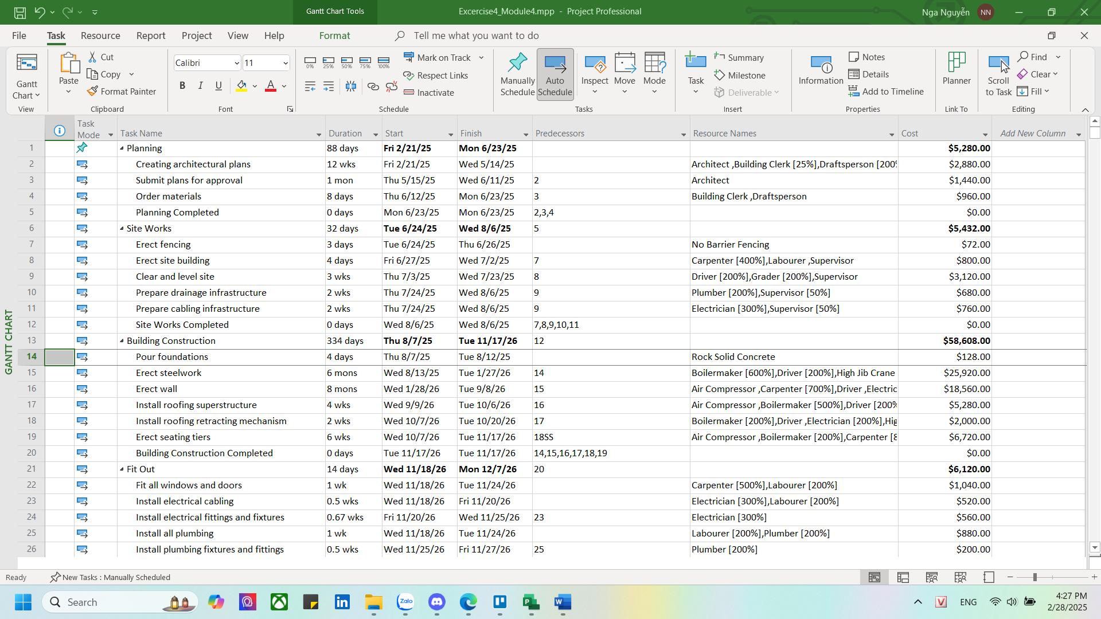

**- Display the Project Information (Statics): Duration, Hours, Cost**

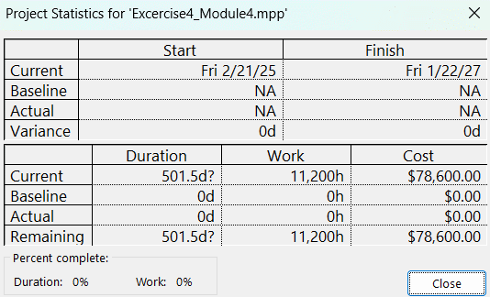

**- Resource Sheet**

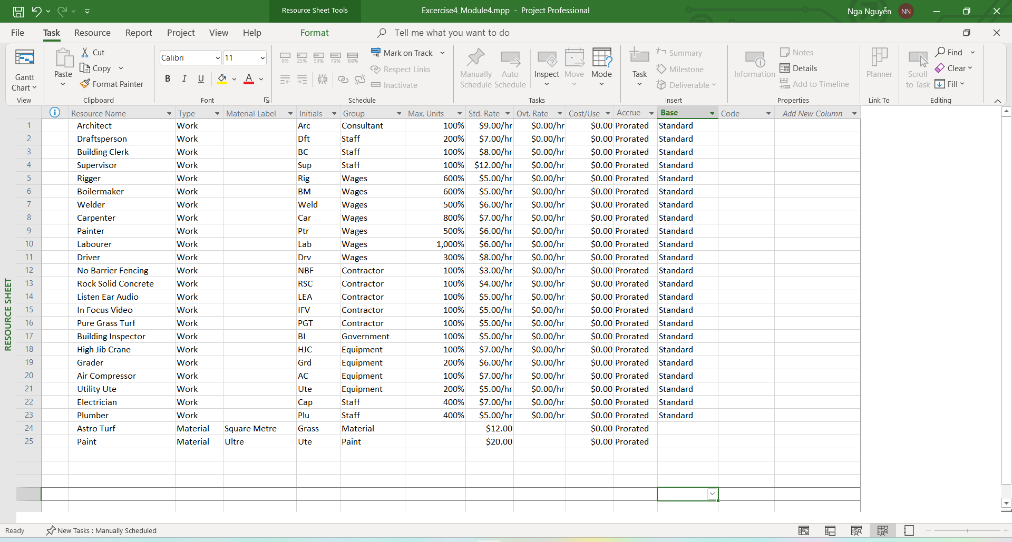

**- Resource Usage**

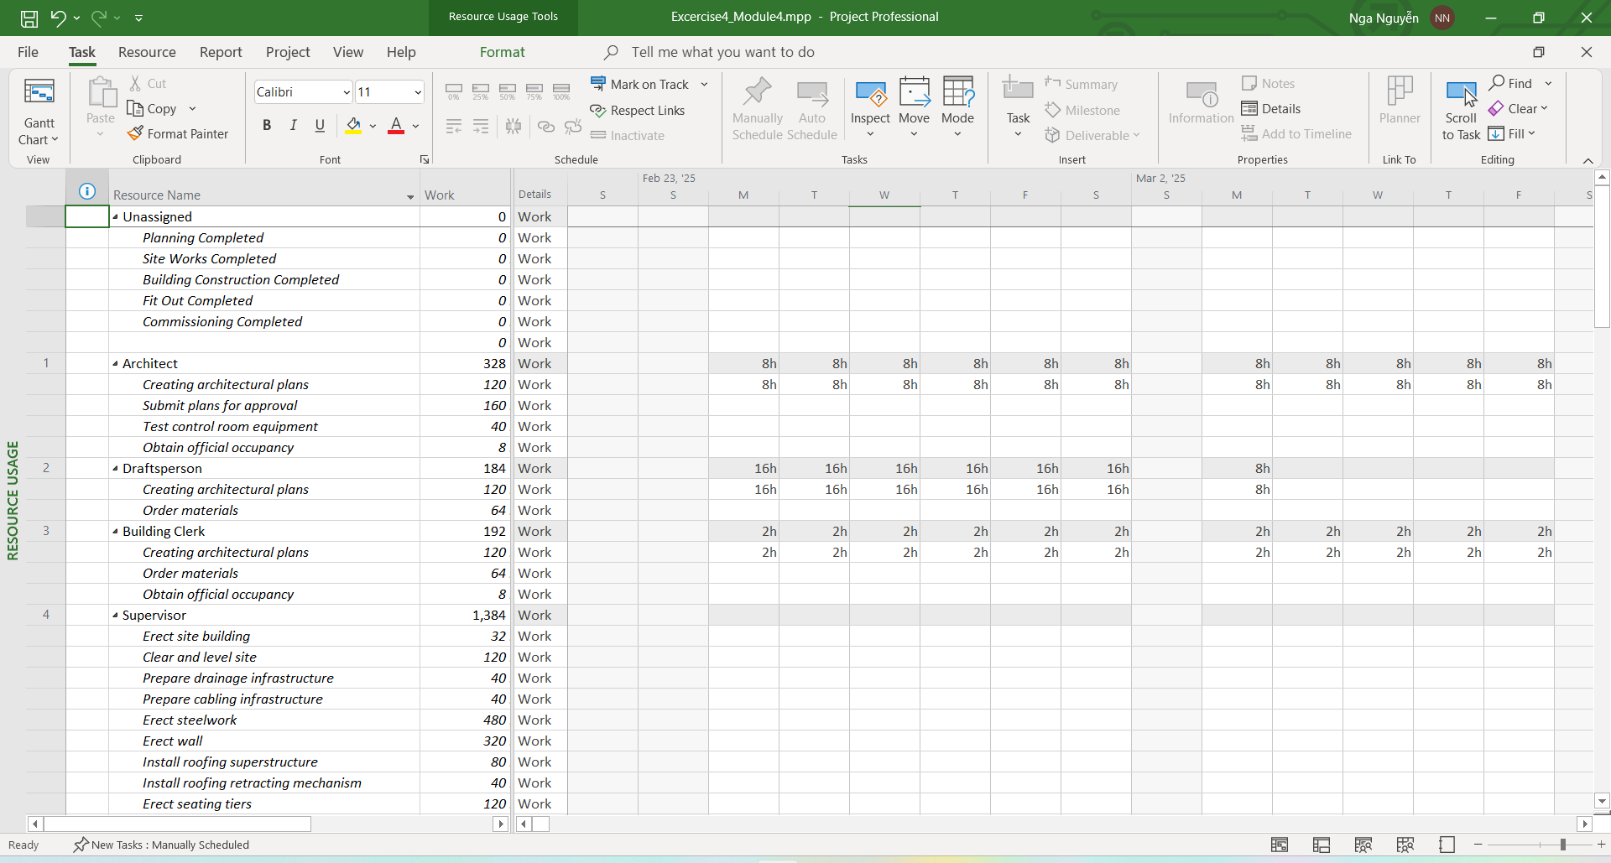

## Exercise 5. Resources with the private working time

* **Creating the Calendars with working times:**

**PM_Time:**

1. Working time: Mon – Sat: 7AM – 11AM

2. Nonworking time: Sun

3. Exception: Nonworking time: 30/4, 1/5, 2/9

**Dev_Time:**

1. Working time: Mon – Fri: 8AM – 11AM, 1PM – 5PM

2. Nonworking time: Sat, Sun

3. Exception: Nonworking time: 30/4, 1/5, 2/9

**Extra_Time:**

1. Working time: Mon – Fri: 6PM – 9PM

2. Nonworking time: Sat, Sun

3. Exception: Nonworking time: 30/4, 1/5, 2/9

**- Creating the following tasks**

|  |  |  |
| --- | --- | --- |
| **Task Name** | **Duration (days)** | **Dependencies** |
| Requirement Analysis | 5 | - |
| Project Planning | 3 | 1 |
| UI/UX Design | 7 | 1 |
| Database Design | 5 | 1 |
| Backend Development | 14 | 4 |
| Frontend Development | 14 | 3 |
| Frontend & Backend Integration | 5 | 5, 6 |
| Testing & Bug Fixing | 7 | 7 |
| Deployment to Test Environment | 3 | 8 |
| Evaluation & Optimization | 5 | 9 |
| Official Deployment | 2 | 10 |
| Maintenance & Support | Ongoing | 11 |

* **Tab View => Resource Sheet / Tab Task => Resource Sheet**

Add the resources this project bellow: Work/Material/Cost

Each Resource bases on a type of working time:

|  |  |  |  |  |  |  |  |
| --- | --- | --- | --- | --- | --- | --- | --- |
| **No.** | **Name** | **Type** | **Quantity** | **Unit** | **Std.Rate** | **Base** | **Related Tasks** |
| 1 | Project Manager | Work | 1 | Person | 20 | PM_Time | Project Planning |
| 2 | System Analyst | Work | 3 | Person | 15 | Extra_Time | Requirement Analysis, Database Design |
| 3 | Backend Developer | Work | 4 | Person | 18 | Dev_Time | Backend Development, Frontend & Backend Integration |
| 4 | Frontend Developer | Work | 3 | Person | 17 | Dev_Time | Frontend Development |
| 5 | UI/UX Designer | Work | 2 | Person | 16 | Extra_Time | UI/UX Design |
| 6 | Tester | Work | 3 | Person | 16 | Dev_Time | Testing & Bug Fixing |
| 7 | Cloud Server (AWS, Azure) | Cost | 1 | Subscription | 200 |  | Data storage, application deployment |
| 8 | Software Licenses | Cost | 1 | Software Package | 99 |  | Deployment to Test Environment |
| 9 | Developer Workstations | Material | 4 | Units | 1200 |  | Deployment to Test Environment |
| 10 | UI/UX Design Tools | Cost | 1 | Software Package | 200 |  | Official Deployment |
| 11 | Testing Tools (Selenium, JMeter) | Cost | 1 | Software Package | 90 |  | Testing & Bug Fixing, Evaluation & Optimization |

**Capture images:**

* Gantt Chart (Resource Name, Cost Column)

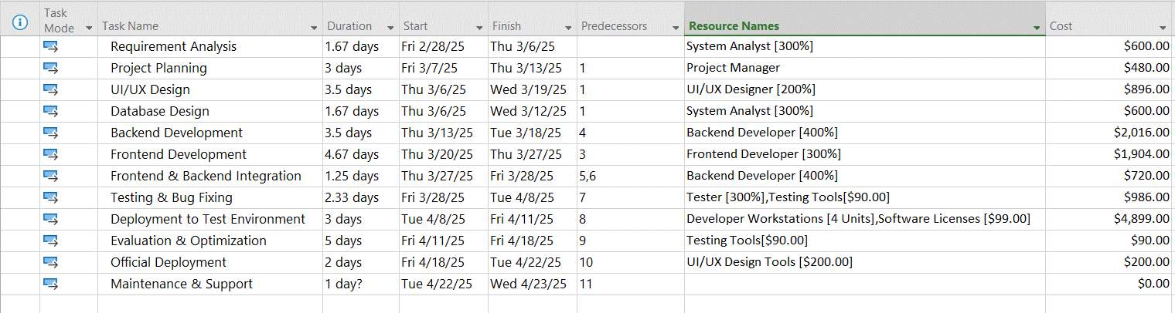

* Display the Project Information (Statics): Duration, Hours, Cost

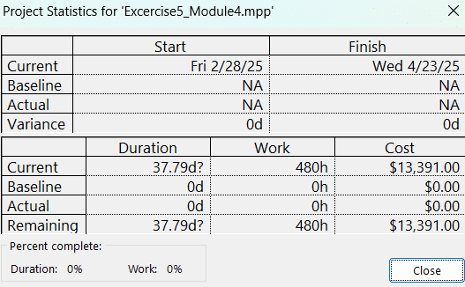

* Resource Sheet

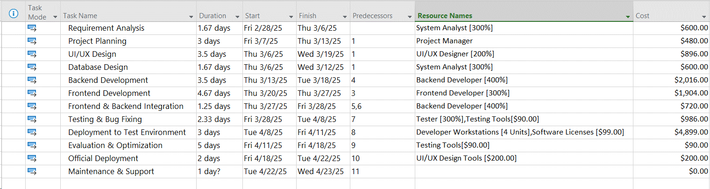

* Resource Usage

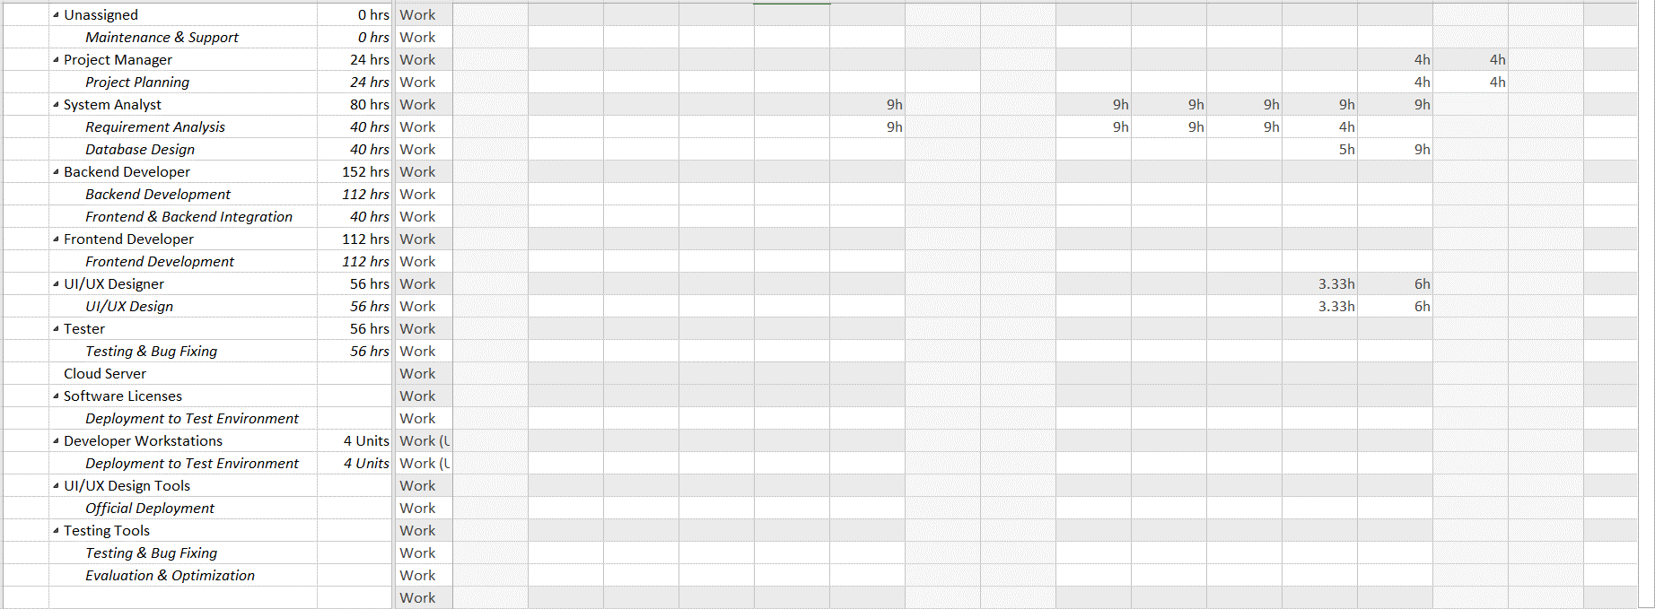

## Exercise 6 :

Creating the following tasks (Project Start Date 6/12/2024)

Establish working time: ***MSSV_Time***

1. Working time: Mon – Fri: 8AM – 11AM, Sat: 11AM-9PM

2. Nonworking time: Sun

3. Exception: Nonworking time: 24/12/2024, 1/1/2022

|  |  |  |  |
| --- | --- | --- | --- |
| **STT** | **Name** | **Duration** | **Dependencies** |
| 1 | The Engagement | 1 day |  |
| 2 | The Venue - Confirm Dates | 4 wks | 1 |
| 3 | The Photographer | 3 wks | 2 |
| 4 | The Cars | 4 wks | 2 |
| 5 | The DJ | 1 wk | 2 |
| 6 | The Dress - Find the Perfect Dress | 3 wks | 2 |
| 7 | The Venue - Confirm Menu | 4 wks | 2 |
| 8 | The Venue - Pay Deposit | 2 hrs | 7 |
| 9 | The Dress - Pay for Dress | 1 hr | 6 |
| 10 | Invitations - Confirm Design | 2 wks | 6 |
| 11 | The Flowers | 2 wks | 6 |
| 12 | Invitations - Confirm Numbers | 1 wk | 10 |
| 13 | Inviations - Invites Produced | 2 mons | 12 |
| 14 | Review progress | 4 wks | 3,4,5,8,9,11,12,13 |
| 15 | Invitations - Send Out | 1 wk | 13 |
| 16 | The Dress - First Fitting | 2 hrs | 9 |
| 17 | Invitations - Review RSVP's | 1 wk | 15 |
| 18 | The Venue - Confirm Numbers | 2 hrs | 17 |
| 19 | The Venue - Confirm Timings | 2 hrs | 18 |
| 20 | The Venue - Pay Balance | 1 hr | 19 |
| 21 | The Dress- Final Fitting | 2hr | 20 |

* Create a milestone task at the end: The Big day (P) (Dependencies: 19,21)
* Creating the summary tasks :
* Before 6 month to go (Task 2,3,4,5,6,7)
* 6 month to go (Task 8,9,10,11)
* 5 month to go (Task 12,13)
* 4 month to go (Task 14)
* 3 month to go (Task 15)
* 2 month to go (Task 16,17)
* 1 month to go (Task 18,19,20,21)
* Establish the resource table:

|  |  |  |  |  |  |  |
| --- | --- | --- | --- | --- | --- | --- |
| **STT** | **Name** | **Type** | **Initials** | **Groups** | **Max. Units** | **Std. Rate** |
| 1 | Venue Material | Material | V | None | None | £3,000.00 |
| 2 | Photgraphs | Material | V | None | None | £1,000.00 |
| 3 | Flowers | Material | P | None | None | £900.00 |
| 4 | Cars | Material | F | None | None | £500.00 |
| 5 | DJ | Material | C | None | None | £250.00 |
| 6 | Guest | Work | D | None | 8000% | £25/1hr |

* Assign the resource for each task in the project

|  |  |  |
| --- | --- | --- |
| **STT** | **Name** | **Resource** |
| 1 |  |  |
| 2 | The Engagement |  |
| 3 | The Venue - Confirm Dates | Venue[1] |
| 4 | The Photographer | Photgraphs[1] |
| 5 | The Cars | Cars[1] |
| 6 | The DJ | DJ[1] |
| 7 | The Dress - Find the Perfect Dress |  |
| 8 | The Venue - Confirm Menu |  |
| 9 | The Venue - Pay Deposit |  |
| 10 | The Dress - Pay for Dress |  |
| 11 | Invitations - Confirm Design |  |
| 12 | The Flowers | Flowers[1] |
| 13 | Invitations - Confirm Numbers |  |
| 14 | Inviations - Invites Produced |  |
| 15 | Review progress |  |
| 16 | Invitations - Send Out |  |
| 17 | The Dress - First Fitting |  |
| 18 | Invitations - Review RSVP's |  |
| 19 | The Venue - Confirm Numbers |  |
| 20 | The Venue - Confirm Timings |  |
| 21 | The Venue - Pay Balance | Guests[7,000%] |
| 22 | The Dress- Final Fitting |  |

# 

# MODULE 5: COST, CONSTRAINS, DEADLINE for TASKs

## Exercise 1. Entering Cost

* Open the Exercise 1 (Module 4) [Cost: $1.984]
* Tab View => Resource Sheet
* Add the resource for this project bellow: Type Cost (Not set value, Rate)

|  |  |  |
| --- | --- | --- |
| **STT** | **Name** | **Type** |
| 11 | Cost Tax | Cost |
| 12 | Logistic Cost | Cost |

Assign Cost for task **Ready for preproduction task (Cost Task: 10$, Logistic Cost: 10$)**

* Cost of project?

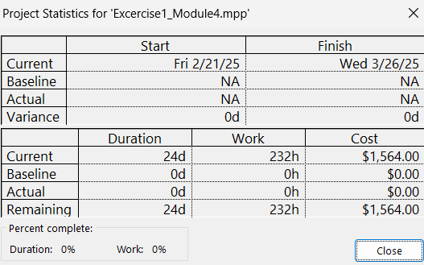

* Update Project after 5 days? Cost of Project?

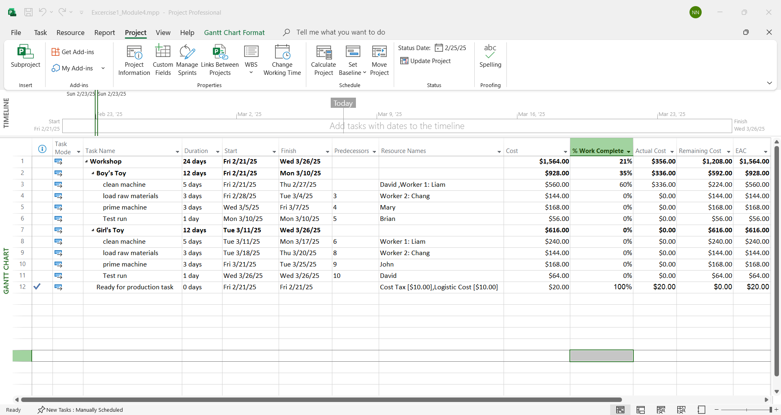

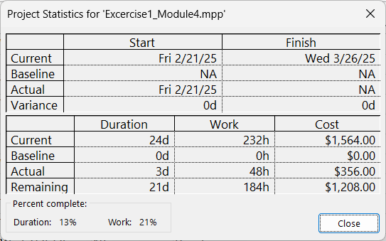

## Exercise 2.

* Exercise 2 (Module 4) Cost: ?
* Tab View => Resource Sheet
* Add the resource for this project bellow: Type Cost (Not set value, Rate)

|  |  |  |
| --- | --- | --- |
| **STT** | **Name** | **Type** |
| 5 | Cost Tax | Cost |
| 6 | Logistic Cost | Cost |
| 7 | OT Cost | Cost |
| 8 | Bonus | Cost |
| 9 | Punishment | Cost |

* Assign Cost for these tasks:

|  |  |  |
| --- | --- | --- |
| **ID** | **TASK NAME** | **RESOURCE** |
| 1 | Visit estate agents | MDF [2], OT Cost[50] |
| 2 | View properties | Flooring [2], Cost Task[3] |
| 3 | Decide what to buy | Purple Material [1], Bonus[12] |
| 4 | Make offer | Flooring [1], Purple Material [1], OT Cost[8], Punish[5] |
| 5 | Wait for decision | Flooring [1], Orange Material [1], Logistic Cost[75] |
| 6 | offer a accepted | Orange Material [2], Bonus[10] |

* Cost of project?

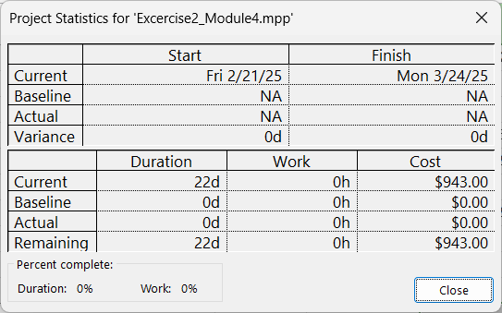

* Update Project after 3 days? Cost of Project?

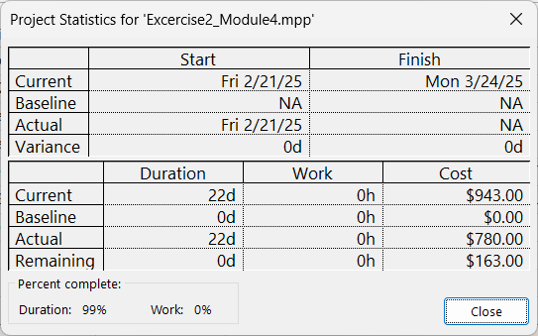

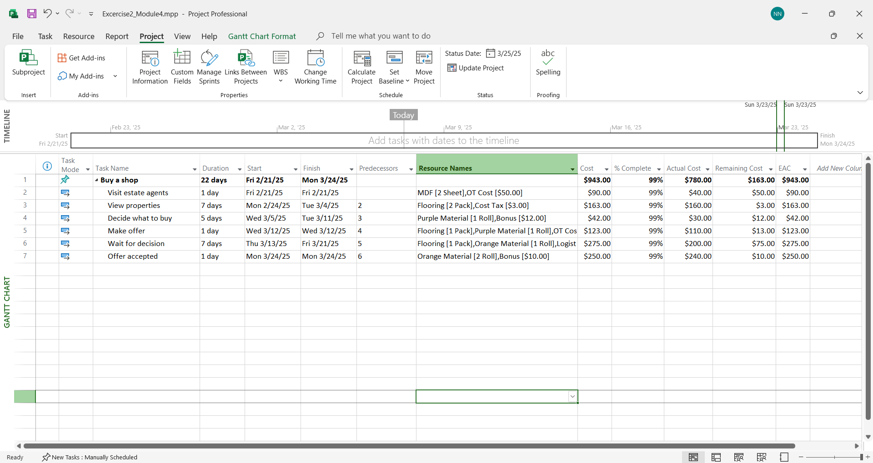

## Exercise 3.

* Exercise 3 (Module 4) Cost: ?
* Tab View => Resource Sheet
* Add the resource for this project bellow: Type Cost (Not set value, Rate)

|  |  |  |
| --- | --- | --- |
| **STT** | **Name** | **Type** |
| 10 | Tax | Cost |
| 11 | Upgrade Fee | Cost |
| 12 | Maintain Fee | Cost |
| 13 | Bonus | Cost |
| 14 | Part Time Fee | Cost |

* Assign the resource for each task

|  |  |  |
| --- | --- | --- |
| **ID** | **TASK NAME** | **RESOURCE** |
| 1 | Planning | PM, Tax[4] |
| 2 | Requirement documents | PM, Designer, Part Time Fee[10] |
| 3 | Sign off | PM |
| 4 | Development | Developer, Operating System[1] , Visual Studio [1], Upgrade Fee[21] |
| 5 | Testing | Tester, Part Time Fee[10], Bonus[18] |
| 6 | Implementation | Maintainer, Operating System , Visual Studio, Cable [100], Maintain Fee[18], Bonus[23] |
| 7 | Review | PM, Maintainer |

* Cost of project?

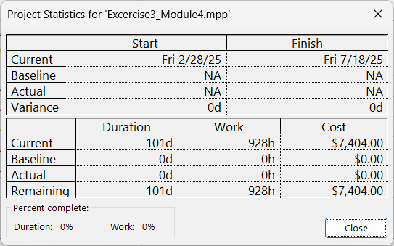

* Update Project after 2 weeks? Cost of Project?

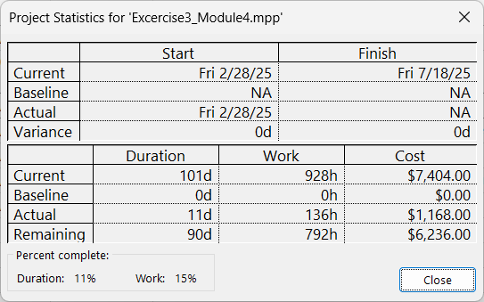

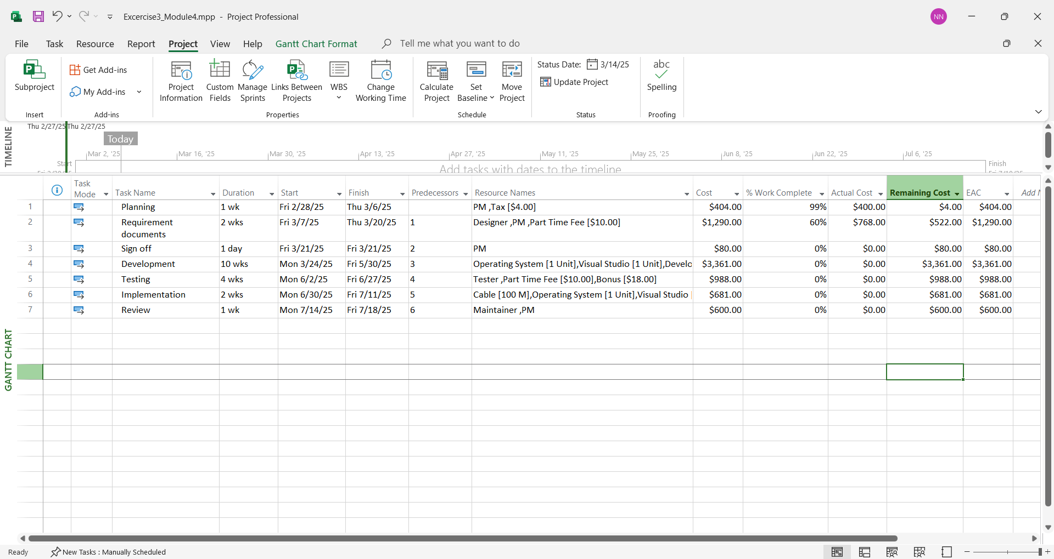

## Exercise 4.

* Exercise 4 (Module 4) Cost: ?
* Tab View => Resource Sheet
* Add the resource for this project bellow: Type Cost (Not set value, Rate)

|  |  |  |
| --- | --- | --- |
| **STT** | **Name** | **Type** |
| 26 | Tax | Cost |
| 27 | Bonus | Cost |
| 28 | Part Time Fee | Cost |
| 29 | Logictis Cost | Cost |

* Assign the resource for each task

|  |  |  |
| --- | --- | --- |
| **ID** | **TASK NAME** | **RESOURCE** |
| 1 | Planning Completed | Part Time Fee[150], Bonus[70] |
| 2 | Site works Completed | Logictis Cost[240] |
| 3 | Building Construction Completed | Logictis Cost[1004], Bonus[210] |
| 4 | Fit out Completed | Tax[50] |
| 5 | Commissioning Completed | Bonus[180] |

* Cost of project?

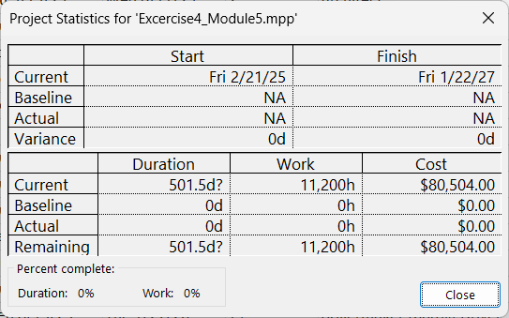

* Update Project after 1 month? Cost of Project? 1/2 - 1/3

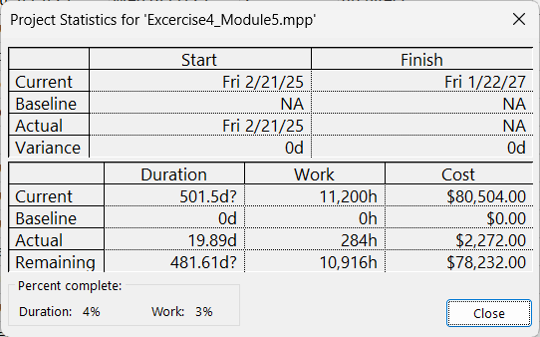

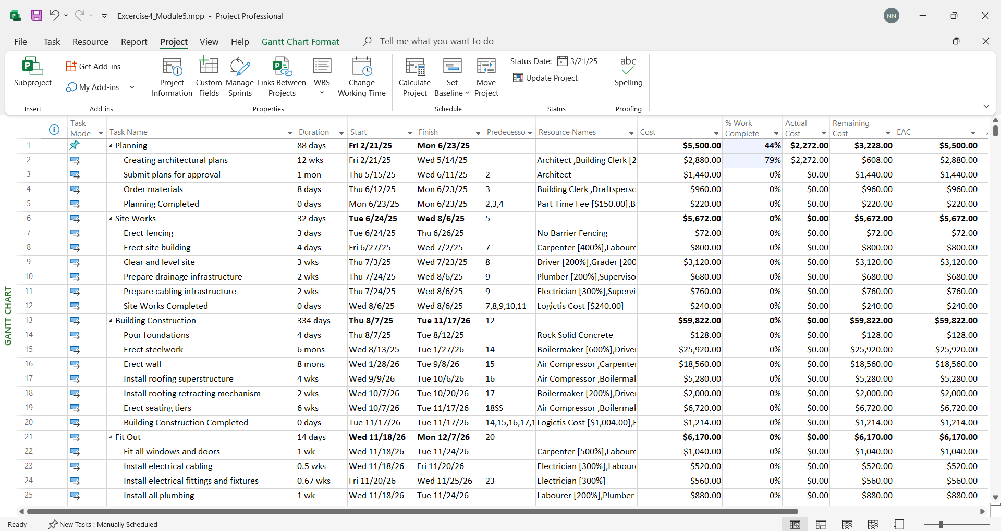

* Update Project after 4,5 month? Cost of Project? 1/2 - 15/3

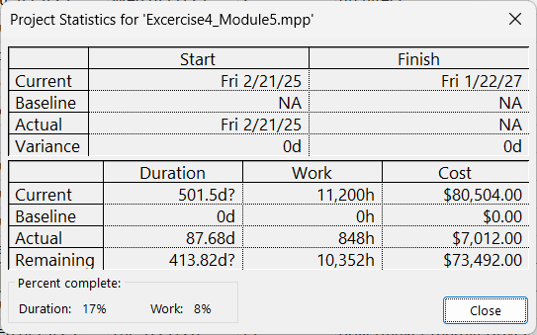

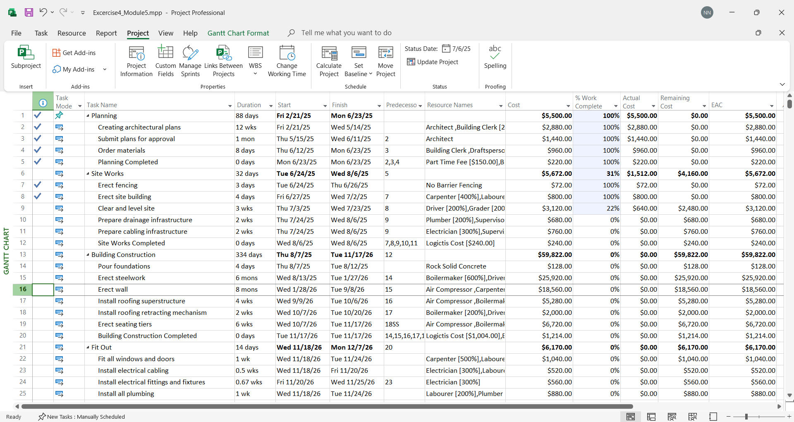

* Update Project after 6 month? Cost of Project? 1/2-1/3-1/4-1/5-1/6-1/7-1/8

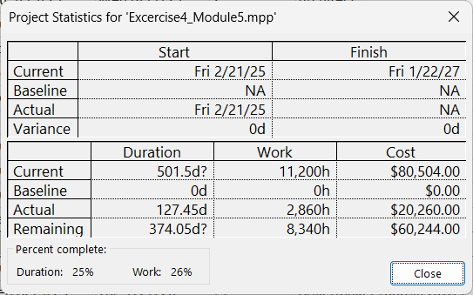

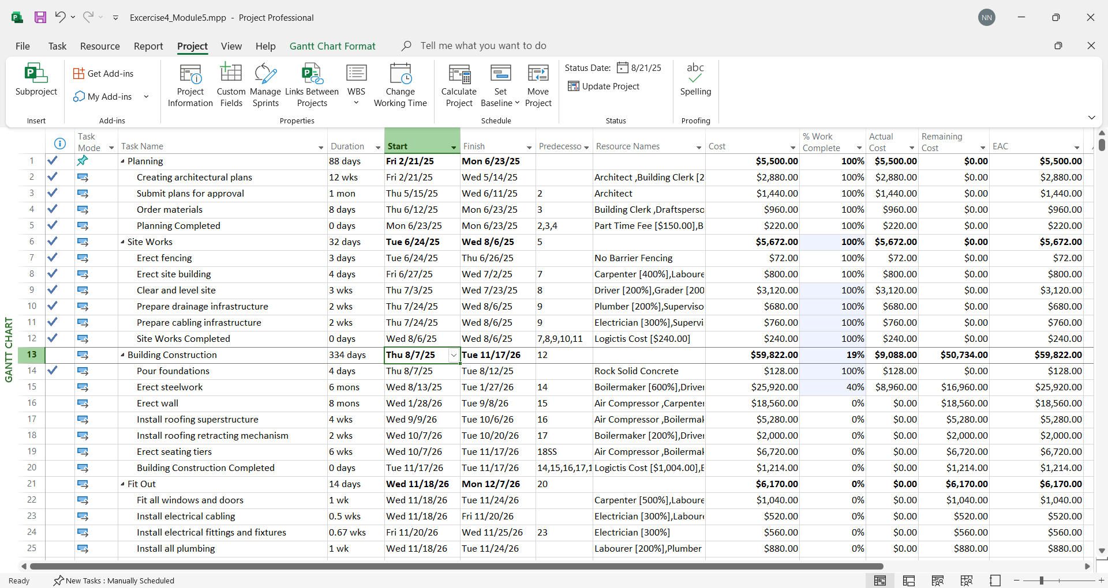

# MODULE 6: HIỂN THỊ DỰ ÁN THEO MỘT SỐ YÊU CẦU- REPORT

## MS Project cho phép hiển thị các task trong dự với các cách khác nhau như:



## Tab View: Hiển thị và cho phép lọc theo các tham số khác nhau

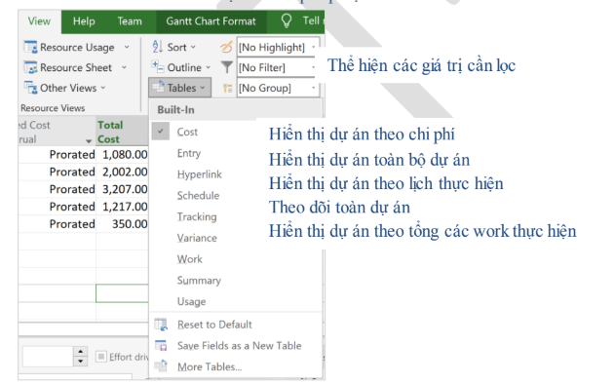

## So sánh các giá trị Cost, Baseline, Variance, Actual



## Xuất các báo cáo (Report) cho dự án

* **Báo cáo theo đồ thị:**

Tab Report => Visual Reports



* **Báo cáo cơ bản dạng số liệu**

Tab Report => View Group



## Bài tập áp dụng:

* + **Cho dự án với danh sách resource**

|  |  |  |  |  |  |  |  |  |  |  |
| --- | --- | --- | --- | --- | --- | --- | --- | --- | --- | --- |
| **Tên Tài Nguyên** | **Loại** | **Vật Liệu** | **Nhãn** | **Ký Hiệu** | **Nhóm** | **Tối Đa** | **Đơn Vị** | **Tỷ Lệ Tiêu Chuẩn** | **Tỷ Lệ Ngoài Giờ** | **Chi Phí/Sử Dụng** |
| Hoàng Mạnh Quân (PM) | Công việc |  | H | HMQ |  | 100% | giờ | 10.00 ₫/giờ | 0.00 ₫/giờ | 20.00 ₫ |
| Lê Hoàng Minh (TV) | Công việc |  | L | LHM |  | 50% | giờ | 20.00 ₫/giờ | 0.00 ₫/giờ | 10.00 ₫ |
| Phạm Minh Vương (TV) | Công việc |  | P | PMV |  | 200% | giờ | 15.00 ₫/giờ | 0.00 ₫/giờ | 30.00 ₫ |
| Lê Lan Phương | Công việc |  | L | LLP |  | 100% | giờ | 15.00 ₫/giờ | 0.00 ₫/giờ | 10.00 ₫ |
| Hoàng Lê Minh | Công việc |  | H | HLM |  | 100% | giờ | 10.00 ₫/giờ | 0.00 ₫/giờ | 0.00 ₫ |
| Mai Hà Linh | Công việc |  | M | MHL |  | 100% | giờ | 15.00 ₫/giờ | 0.00 ₫/giờ | 10.00 ₫ |
| Trần Ngọc Hà | Công việc |  | T | TNH |  | 200% | giờ | 15.00 ₫/giờ | 0.00 ₫/giờ | 10.00 ₫ |
| Bùi Hoàng Quyên | Công việc |  | B | BHQ |  | 100% | giờ | 15.00 ₫/giờ | 0.00 ₫/giờ | 10.00 ₫ |
| OS | Vật liệu | OS | O | OS |  |  |  | 250.00 ₫ | 0.00 ₫ |  |
| Hardisk | Vật liệu | Hardisk | H | Hardisk |  |  |  | 120.00 ₫ | 0.00 ₫ |  |
| USB | Vật liệu | USB | U | USB |  |  |  | 1.00 ₫ | 0.00 ₫ |  |
| Framework | Vật liệu | Framework | F | Framework |  |  |  | 80.00 ₫ | 2.00 ₫ |  |
| Chi phí đi lại | Chi phí |  | C | CPDL |  |  |  |  |  |  |
| Chi phí công tác | Chi phí |  | C | CPCT |  |  |  |  |  |  |
| Thuế | Chi phí |  | T | Thue |  |  |  |  |  |  |

* + **Cho dự án với các công việc có gán các resource như sau:**

|  |  |  |  |  |
| --- | --- | --- | --- | --- |
| **STT** | **Tên công việc** | **Thời lượng** | **Công việc trước** | **Tên tài nguyên** |
| 1 | Khảo sát | 2 ngày | - | Bùi Hoàng Quyên, Thuế [20.00] |
| 2 | Phân tích | 4 ngày | 1 | Framework [1], Lê Lan Phương [200%], Chi phí đi lại [5.00] |
| 3 | Thiết kế | 7 ngày | 2 | OS [2], Trần Ngọc Hà |
| 4 | Xây dựng | 0.5 tháng | 3 | Trần Ngọc Hà, Hardisk [0.5] |
| 5 | Kiểm thử | 1 tuần | 4 | Hoàng Mạnh Quân (PM), Thuế [10.00] |
| 6 | Chuyển giao | 4 ngày | 5 | Lê Hoàng Minh (TV) [50%], Mai Hà Linh, Chi phí công tác [100.00] |
| 7 | Hướng dẫn sử dụng | 3 ngày | 6 | Phạm Minh Vương (TV), Chi phí đi lại [10.00] |

**Yêu cầu:**

1. Nhập thông tin dự án, gắn các loại tài nguyên cho các công việc của DA theo đề bài.

* Chụp kết quả Gantt Chart.

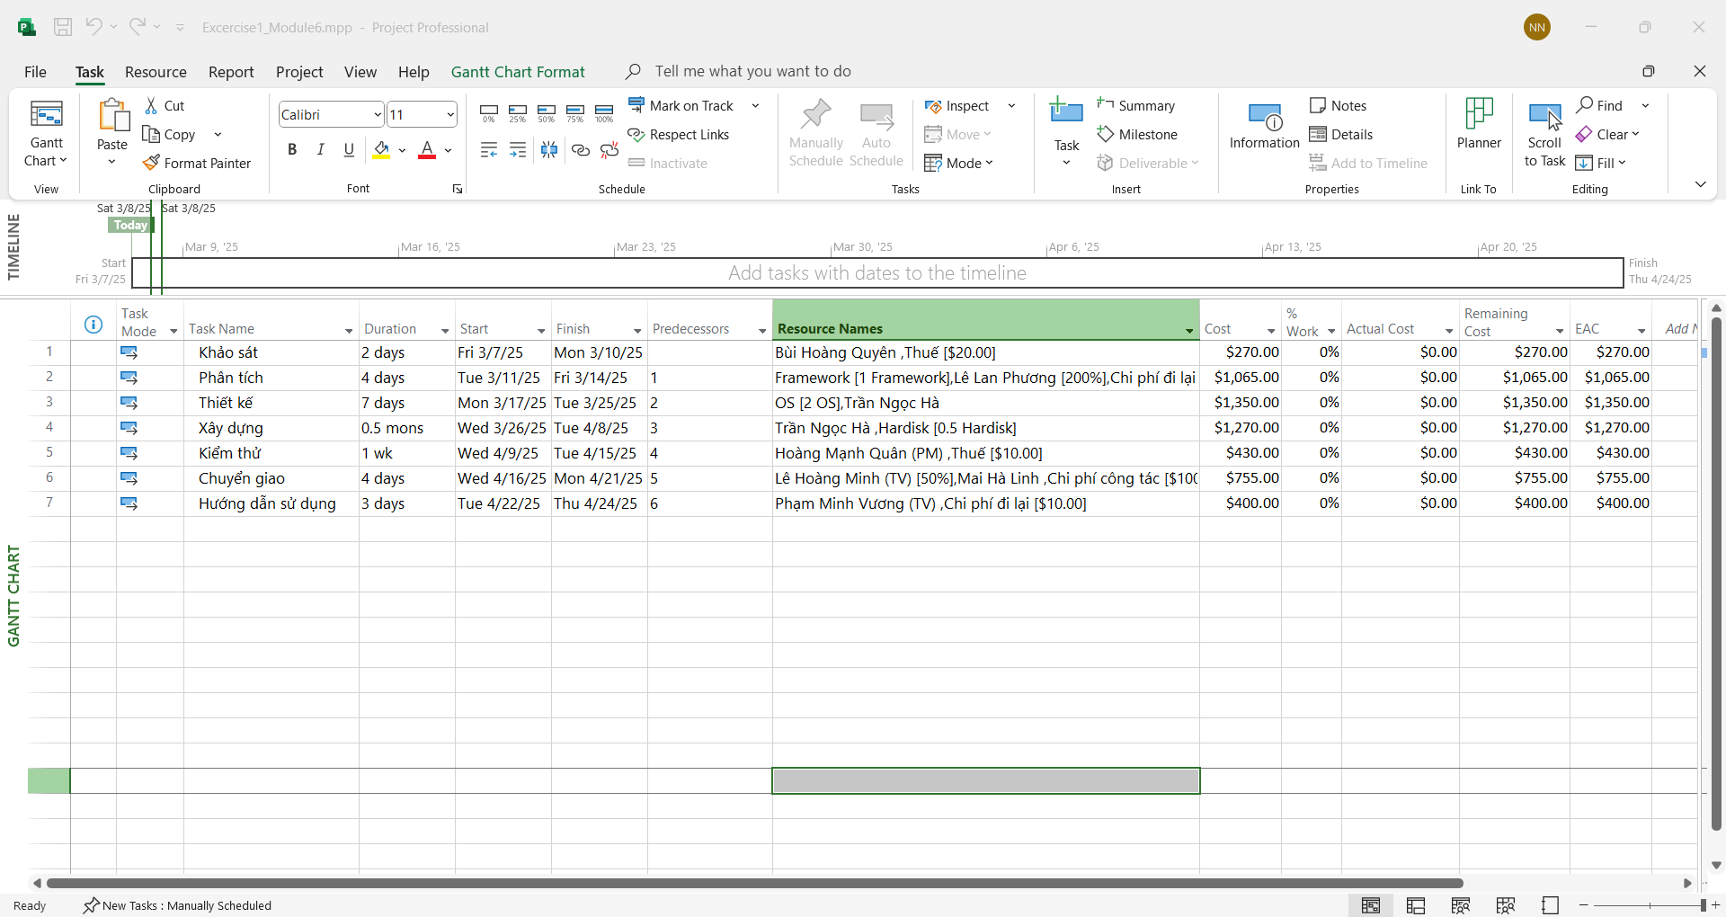

* Chụp Project Information (Statistics)

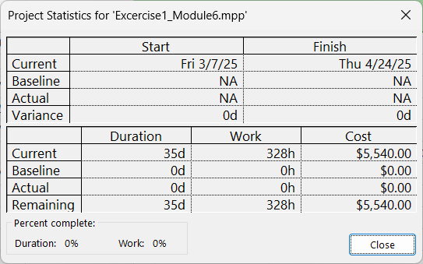

* Chụp hình Resource Sheet

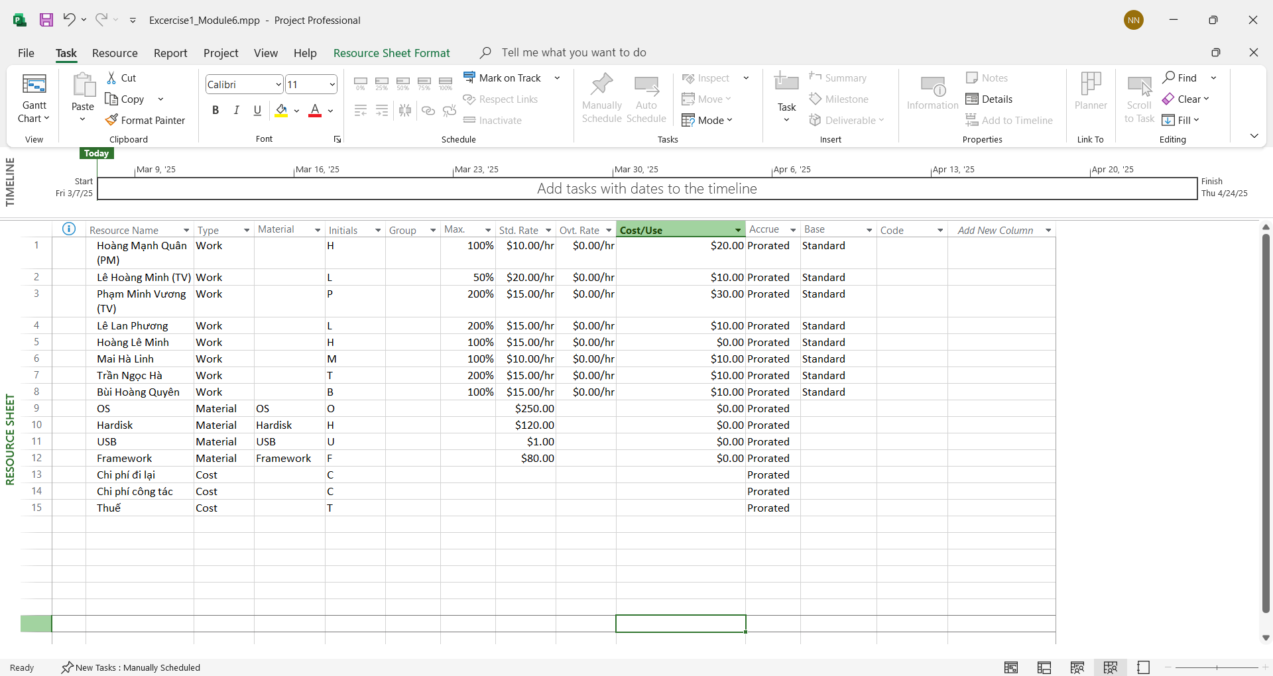

**2. Chụp hình các báo cáo của dự án (Report)**

**Dashboard:**

**Project Overview**

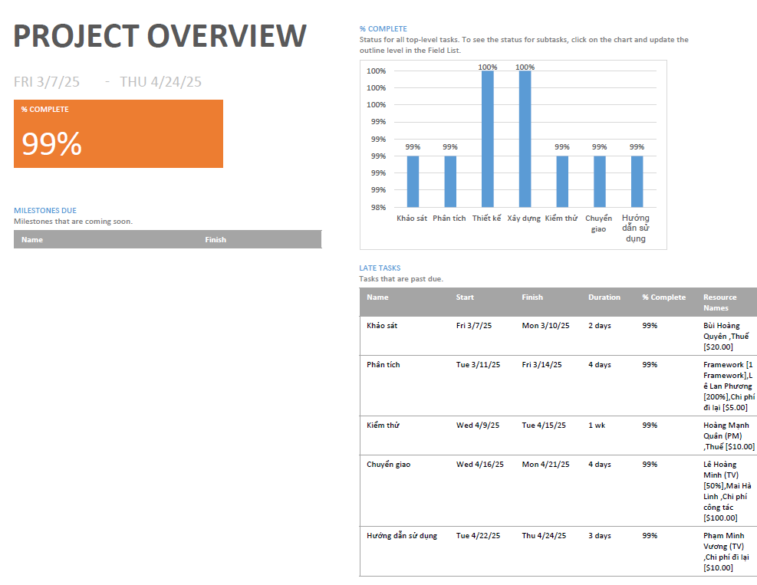

**Cost Overview**



**Work Overview**



**Resource Cost Overview**



**Progress**

**Critical Tasks**

